Table of Contents

Acknowledgement ............................................................................................................ |  |  | ii
Chapter:1 Introduction ..................................................................................................... |  |  | 1
1.1 | Introduction of subject matter ................................................................................ |  | 1
1.2 | Problem & project as solution ................................................................................ |  | 1
1.3 | Aims & Objectives .................................................................................................. |  | 2
1.3.1 |  | Aims .................................................................................................................... | 2
1.3.2 |  | Objectives ........................................................................................................... | 2
1.4 | Report Structure .................................................................................................... |  | 3
1.4.1 |  | Background Study .............................................................................................. | 3
1.4.2 |  | Initial Designs ..................................................................................................... | 3
1.4.3 |  | Development ....................................................................................................... | 3
1.4.4 Testing ................................................................................................................ |  |  | 3
1.4.5 |  | Evaluation ........................................................................................................... | 3
1.4.6 |  | Legal, Social & Ethical issues ............................................................................. | 4
1.4.7 |  | Conclusion & Further Enhancements ................................................................. | 4
Chapter 2: Background Study ......................................................................................... |  |  | 5

2.1 Literature Review 5

2.2 Similar Apps 5

2.2.1 Comparison of similar applications 9

2.2.2. Review of similar applications 10

2.2.3 Technical Aspects 10

2.2.4 Tools used in Project 11

Chapter 3. Development 12

3.1 Considered Methodology 12

Prototype Model: 12

Prototype Model - style 12

3.2. Selected Methodology with reasons 14

3.3. Requirement Collection: 15

3.3.1. Feasibility Study: 15

3.3.2. Prototyping: 16

3.3.3. Design: 17

3.3.4. Coding: 17

3.3.5. Testing & Debugging: 17
Chapter 4 : Design 18

Objectives: 18

Goals : 18

4.1. Wireframe Design 19

4.1.1. Initial Wireframe Design 19

Home Page including Login option layout: 20

Login Screen Layout: 21

Admin Dashboard Layout: 22

Student Dashboard Layout : 23

4.1.2 Final Wireframe Design: 24

4.2 UI Design: 24

4.3 System Architecture: 27

4.4 Use Case Diagram: 29

4.5 Class Diagram: 32

4.6 Entity Relationship ( ER ) Diagram: 32

Chapter 5: Implementation: 34

Chapter 6: Testing 45
Unit Testing 45

Testing Plan 49

Test Cases: 51

Chapter 7: Evaluation of Testing 71

7.1 Evaluation done by the system users 71

7.2 Critical Evaluation 71

Chapter :9 Conclusion 73

References: 74

Appendix-A. 76

Survey Outcomes: 76

Appendix-B. 79

Gantt chart 79

Appendix-C. 80

Software Requirement Specification 80

Purpose 80

Intended Audience 80

Project Scope 80
Overall description: 81

Product perspective 81

Product features 81

User characteristics: 81

Operating environment 81

Constraint 81

Assumption 81

System features 82

External Interface Requirement: 82

User interface: 82

Hardware interface: 82

Software interface: 82

Communication interface: 83

Non – Functional Requirement: 83
Table of Figures

Figure 1: NZ LIBRARY MANAGEMENT SYSTEM 6

Figure 2:RFID LIBRARY MANAGEMENT SYSTEM 7

Figure 3 CICERO LIBRARY MANAGEMENT SYSTEM 8

Figure 4: Process of Prototype Model 13

Figure 6 Home Page including Login option layout 20

Figure 5: Initial Layout of First Screen layout 20

Figure 7 Login Screen Layout 21

Figure 8 Admin Dashboard Layout 22

Figure 9 Student Dashboard Layout 23

Figure 10: UI Design Of Home Page including Login option 24

Figure 11: UI Design Of Login Screen 25

Figure 12 UI Design Of Admin Dashboard 25

Figure 13 UI Design Of Student Dashboard 26

Figure 14 Admin System Architecture 27

Figure 15 Members System Architecture 28

Figure 16 Use Case Diagram of Admin 30
Figure 17 Use Case Diagram of Member 31

Figure 18: Class Diagram of LIBRARY MANAGEMENT SYSTEM. 32

Figure 19: Entity Relationship Diagram of LIBRARY MANAGEMENT SYSTEM. 33

Figure 20 Startup of Sublime Text Editor 34

Figure 21: Coding of Library Management System in Sublime 35

Figure 22: Database Of My Project 35

Figure 23: Database of Admin 36

Figure 24: Database of books 36

Figure 25 Database of Borrow Books 37

Figure 26 Database of Announcement News 37

Figure 27 Database of Students 38

Figure 28: Home Page 39

Figure 29: Login Screen 39

Figure 30: Admin Dashboard 40

Figure 31: Add Book Screen 40

Figure 32: Add Admin Screen 41

Figure 33: Add Student Screen 41
Figure 34 View Borrowed Books Screen 42

Figure 35: Stop Counting Fines Screen 42

Figure 36 Student Dashboard 43

Figure 37 View Student Profile Screen 43

Figure 38 Borrow Books Screen 44

Figure 39 Check Fines Screen 44

Figure 40 Test Case 1 Before 51

Figure 41 Test Case 1: After 52

Figure 42 Test Case 2: Before 52

Figure 43 Test Case 2: After 53

Figure 44 Test Case 3: Before 54

Figure 45 Test Case 3: After 54

Figure 46 Test Case 4: Before 55

Figure 47 Test Case 4: After 55

Figure 48 Test Case 5: Before 56

Figure 49 Test Case 5:After 56

Figure 50 Test Case 6: Before 57
Figure 51 Test Case 6:After 58

Figure 52 Test Case 7: Before 59

Figure 53 Test Case 7: After 59

Figure 54 Test Case 8: Before 60

Figure 55 Test Case 8: After 60

Figure 56 Test Case 9: Before 61

Figure 57 Test Case 9: After 62

Figure 58 Figure 59 Test Case 10: After 63

Figure 59 Test Case 11: Before 63

Figure 60 Test Case 11: After 64

Figure 61 Test Case 12: After 65

Figure 62 Taste Case 13: Before 66

Figure 63 Taste Case 13: After 66

Figure 64 Test Case 14: After 67

Figure 65 Test Case 15: Before 68

Figure 66 Test Case 15: After 68

Figure 67 Test Case 16: After 69
Figure 68 Test Case: 17 After 70

Figure 69 SURVEY REPORT 1 76

Figure 70: SURVEY REPORT 2 76

Figure 71 SURVEY REPORT 3 77

Figure 72: SURVEY REPORT 4 77

Figure 73: SURVEY REPORT 5 78

Figure 74 Gantt Chart 79
FYP PROJECT: LIBRARY MANAGEMENT SYSTEM 05/08/2019

Chapter:1 Introduction

1.1 Introduction of subject matter

“Library Management System” monitors & controls library books management transactions in library. the project is developed in php & java which concentrates on main operations that takes place in school library such as adding new member, new books, updating record of issued & returned books etc. the system is easy to use for both beginner & advanced users since it is very easy to operate with easy process for its implementation. Most of its features are familiar & well thought-out along with attractive user interface.

This project will fulfill most of requirements of librarian for record keeping of library books systematically, easily & according to various categories. For student, after getting membership in system, student can login with his/her correct user name & password for borrowing his/her desired books. the library management system is dynamic system so admin can keep record of books & members dynamically which is very easy to operate & can add, delete & update books & members easily in the system.

1.2 Problem & project as solution

There are different types of problems & difficulties of library in school which are suffered by teachers, students & parents as well & the problems had to be eliminated for success of library management. Some of problems which are suffered by most of school related to library are mentioned below:

- It is hard for librarian to keep record of thousands of books manually.

- Managing library manually is time consuming, ineffective & it is not systematic at all.

- There is chance of losing & misplacing of library books.

- Due to lack of proper system library management system is unable to be updated properly.

1

Padam-Gurung(17031979)

FYP PROJECT: LIBRARY MANAGEMENT SYSTEM 05/08/2019

- Students are unable to get necessary books due to unorganized library system.

So, for solution my project named "Library Management System" can be helpful. Main purpose to build the project is to manage library books properly & systematically. In system, admin can add details of books that are kept in school/college library & admin & student member can access information easily. After getting membership in library by admin, the student member can login to student dashboard of my project for borrowing his/her desired books. the library management system is dynamic system so admin can keep record of books & members dynamically which is very easy to operate & can update, add & delete books & members easily in the system.

1.3 Aims & Objectives

1.3.1 Aims

Aim of the project is to develop web application named. The Library Management System aims to keep records of transactions of books available in library. It can be used by everyone who are registered as member in system. It is very easy to use & it fulfills requirement of librarian.

1.3.2 Objectives

- Easy way to enter details of new books.

- Easy way to keep record information of book

- Easy way to issue books to students.

- Easy way to keep record of returned book which were borrowed before.

- Easy way to view books available in library.

- Add & deletion of library members & their registration.

- Update, add & deletion of books details.

- User friendly & secure library management system along with admin login & student login for its operation.

2

Padam-Gurung(17031979)

FYP PROJECT: LIBRARY MANAGEMENT SYSTEM 05/08/2019

1.4 Report Structure

Beside topic above, main body of the report will consist of following topics.

1.4.1 Background Study

In the section, report will include in-depth analysis of the project & how it will impact in current schools/colleges. Along with that the section will also include similar project found in current market & how it is different with current available project.

1.4.2 Initial Designs

In the section, report will include design documents for project & it will include flowcharts, Use case diagrams, Entity Relationship Diagrams, Class diagrams & sequence diagram.

1.4.3 Development

In the section, report will include how will development take place & what methodologies will be taken to develop project.

1.4.4 Testing

In the section of report test logs for project are included along with bugs fixing found in initial state of development. the section also proves that proposed functionality of project works correctly.

1.4.5 Evaluation

In the section, evaluation of system developed is done on basis of conducted surveys & also contains SWOT analysis of project.

3

FYP PROJECT: LIBRARY MANAGEMENT SYSTEM 05/08/2019

1.4.6 Legal, Social & Ethical issues

In the section, legal, social & ethical aspects that can be affected due to implementation of developed project are listed down.

1.4.7 Conclusion & Further Enhancements

This part contains summary of report & further enhancement of system.

4

Padam-Gurung(17031979)

FYP PROJECT: LIBRARY MANAGEMENT SYSTEM 05/08/2019

Chapter 2: Background Study

2.1 Literature Review

This “Library Management System” is based on library of schools/colleges. Even though no documentation is found for review, library of few schools in town had been observed to help understand problem of managing school library system. During project development, plenty of international & national e-library was observed by internet. I had visited various e-libraries such as DCMO BOCES School Library System, NASSAU BOCES School Library System, Western Suffolk BOCES School Library System etc.

project starts by reviewing product of famous organization across globe & some of famous local organizations. Many of school do not had library management system. they were interested to use library management system only when recommended. the is found to be one of major points which are not addressed. I had also read books like Advanced Web Designing, Web Book of Robert Schifrin, etc

2.2 Similar Apps

We can find many similar Library Management System web app that manage

Library. Some of them are:

- NZ LIBRARY MANAGEMENT SYSTEM:

‘NZ Library Management System’ is complete solution for any kind of library maintenance. Specially for Mobile library. the CMS Includes almost everything needed in library. Multiple categories for single book, Book issue system for library members, Messaging inside members etc. In system admin can manage complete website without having single line knowledge of coding or programming. the Library Management System allows multiple admin & multiple manager & members. (Nazrul Islam, 2017)

5

Padam-Gurung(17031979)

FYP PROJECT: LIBRARY MANAGEMENT SYSTEM 05/08/2019
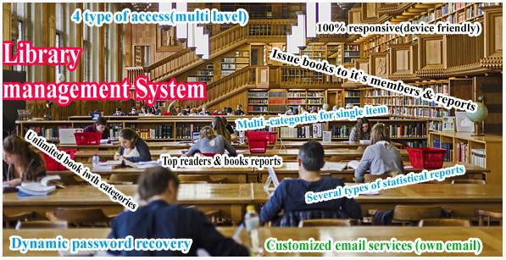

Figure 1: NZ LIBRARY MANAGEMENT SYSTEM

- RFID LIBRARY MANAGEMENT SYSTEM:

RFID (Radio Frequency Identification) is latest technology to be used in library aft detection systems. Unlike EM (Electro-Mechanical) & RF (Radio Frequency) systems, which had been used in libraries for decades, RFID-based systems move beyond security to become tracking systems that combine security with more efficient tracking of materials throughout library, including easier & faster charge & discharge, inventorying, & materials handling. (M Waddenkeri, 2006)

6

FYP PROJECT: LIBRARY MANAGEMENT SYSTEM 05/08/2019
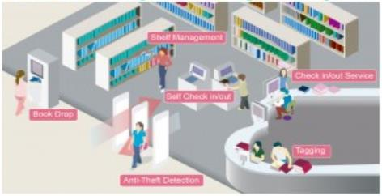

Figure 2:RFID LIBRARY MANAGEMENT SYSTEM

- CICERO LIBRARY MANAGEMENT SYSTEM

Cicero Library Management System (LMS) ensures user-friendly administrative system that’s cost-effective in operation. the ease of use provides staff with effective support for procedures that include administrative search, & advanced decision-making support with regard to purchasing, booking, dealing with library materials & fees. System frees up more time for another tasks. (CICERO)

7

Padam-Gurung(17031979)

FYP PROJECT: LIBRARY MANAGEMENT SYSTEM 05/08/2019
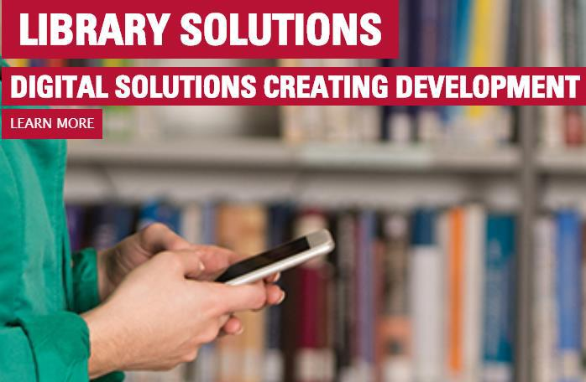

Figure 3 CICERO LIBRARY MANAGEMENT SYSTEM

8

Padam-Gurung(17031979)

FYP PROJECT: LIBRARY MANAGEMENT SYSTEM 05/08/2019

2.2.1 Comparison of similar applications Comparison table of Applications

Features | NZ-LMS | RFID-LMS |  | Cicero-LMS |  | My Project
Mission | Library | To be used in |  | Effective | support | To monitor &
 | maintenance | library | aft | for purchasing, |  | control
 | speciallyfor | detection |  | booking, | dealing | transaction
 | mobile library. | system. |  | in library. |  | of books in
 |  |  |  |  |  | library.
Create | Yes | Yes |  | Yes |  | Yes
Account
Login | Yes | Yes |  | Yes |  | Yes
Chat system | Yes | No |  | Yes |  | No
Payment | Yes | Yes |  | Yes |  | No
methods
Fee | Paid | Paid |  | Paid |  | Free

9

Padam-Gurung(17031979)

FYP PROJECT: LIBRARY MANAGEMENT SYSTEM 05/08/2019

2.2.2. Review of similar applications

During my research I had found report some similar types of project & applications. Some of application are mentioned above. From the application I learned many things which is necessary for my project. From the applications it help to develop project with functional requirements. I found some defects from the application which can easy to implement in my project. User interface from above projects inspired me to make my project design & look different.

2.2.3 Technical Aspects

Technologies used for creating the library management system are mentioned below:

- HTML & CSS: HTML is used to define elements of contents & CSS is used to give 'm appearance & feel.

- PHP: PHP is important tool for creating website which is easy to use for making dynamic website.

- MySQL: It is popular open sources RDBMS due to its high performance, effectiveness & easy for using.

- JavaScript: JavaScript is dynamic computer programming language that is usually used as part of web browsers.

10

Padam-Gurung(17031979)

FYP PROJECT: LIBRARY MANAGEMENT SYSTEM 05/08/2019

2.2.4 Tools used in Project

Web based application development is main part of my project. For development of web application, I had used following tools:

- XAMPP Control Panel

- Sublime Text Editor

Integrated development environment which contains code editor that developer accesses through single graphical user interface. Helpful key shortcuts & simplicity of Sublime Text made me use it.

11

Padam-Gurung(17031979)

FYP PROJECT: LIBRARY MANAGEMENT SYSTEM 05/08/2019

Chapter 3. Development

3.1 Considered Methodology

Prototype Model:

Software development methodology is very important for project. Methodology I will be using in the project is prototype model. Prototype model is well-known version of systems development life cycle model.

Prototyping Model is Systems Development Methodology (SDM) within which paradigm output (or early approximation of final system or product) is constructed, tested, & reworked. It is done till appropriate paradigm is achieved to help develop entire system or product. the model works best in situations when all details or requirements are not known well in advance. It is majorly trial-&-error process which works in iterative fashion.

Prototype Model - style

Prototyping model is also popular software development life cycle model. Prototyping model can be considered to be extension of Iterative Waterfall model. the model suggests building working Prototype of system, before development of actual software.

Following illustration is illustration of various phases of body of Prototype Model:

12

Padam-Gurung(17031979)

FYP PROJECT: LIBRARY MANAGEMENT SYSTEM 05/08/2019
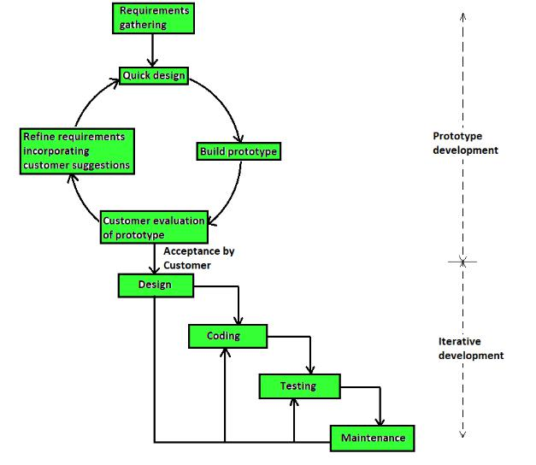

Figure 4: Process of Prototype Model

Phases of Prototype model are −

- 1. Requirements gathering & analysis: Prototyping model begins with requirements analysis & requirements of system defined in detail. User is interviewed in order to know requirements of system.

- 2. Quick design: When requirements are known, preliminary design or quick design for system is created. It is not detailed design & includes only important aspects of system, which gives idea of system to user. Quick design helps in developing prototype.

13

Padam-Gurung(17031979)

FYP PROJECT: LIBRARY MANAGEMENT SYSTEM 05/08/2019

- Build prototype: Information gathered from quick design is modified to form first prototype, which represents working model of required system.

- 4. User evaluation: Next, proposed system is presented to user for thorough evaluation of prototype to recognize its strengths & weaknesses such as what is to be added or removed. Comments & suggestions are collected from users & provided to developer.

- 5. Refining prototype: Once user evaluates prototype & if he is not satisfied, current prototype is refined according to requirements. That is, new prototype is developed with additional information provided by user. new prototype is evaluated just like previous prototype. the process continues until all requirements specified by user are met. Once user is satisfied with developed prototype, final system is developed on basis of final prototype.

- 6. Engineer product: Once requirements are completely met, user accepts final prototype. final system is evaluated thoroughly followed by routine maintenance on regular basis for preventing large-scale failures & minimizing downtime.

All these phases are cascaded to each another in which progress is seen as flowing steadily downwards (like waterfall) through phases. next phase is started only after defined set of goals are achieved for previous phase & it is signed off, so name "Waterfall Model". In the model, phases do not overlap.

3.2. Selected Methodology with reasons

This model is most appropriate for projects that suffer from technical & requirements risks. constructed prototype helps to overcome the risks. Some of major advantages of Prototype Model are as follows −

- Simple & easy to understand & use. Users are actively involved in development.

14

Padam-Gurung(17031979)

FYP PROJECT: LIBRARY MANAGEMENT SYSTEM 05/08/2019

- Since in the methodology working model of system is provided, users get better understanding of system being developed.

- Errors can be detected much earlier.

- Quicker user feedback is available leading to better solutions.

- Missing functionality can be identified easily.

- Confusing or difficult functions can be identified.

3.3. Requirement Collection:

3.3.1. Feasibility Study:

In many aspects, problem seems to be feasible. Some aspects of feasibility study are discussed below in detail.

Technical feasibility

Due to rapid advancement in IT, technical devices are available everywhere in affordable prices. Also it can be used by any kind of people who had little knowledge about computer & internet. So we can say that the project is technically possible.

Economic feasibility

It is related with issue of cost –effectiveness of system. It includes all cost that will be incurred for resources that is used to develop system. For purpose of economic feasibility we had used cost benefit analysis techniques. required resources such as hardware (CPU, storage devices, printer, floppy disks, etc) are already present with user as well as with company so cost of computer usage is least. Only overhead cost associated with maintenance can be incurred. In considerations with ase factors project is economically feasible.

Social & another aspects

15

Padam-Gurung(17031979)

FYP PROJECT: LIBRARY MANAGEMENT SYSTEM 05/08/2019

Project is feasible from social aspect. Intension of developing library management system of school is clearly social matter. As it is library management system of school, we can easily trust on content & intension of system development project.

Time Feasibility

Project is to be developed by individual effort without hiring any oar helpers it is very difficult to complete project within time. But due to kind support of project guide & supervisor project can be accomplished in specified time.

Legal Issues

This project is student oriented so it will not involve any legal conflicts.

Development of website for organization is entirely in its right..

3.3.2. Prototyping:

Testing application of system was started with putting together working features for testing purpose only. the way various aspects of design, illustrated ideas & features of system can be tested & early feedback can be gained. By getting feedback from people about system prototype can be improved. So for that purpose development of system was started by taking only two features of system. the way all focus for initial development phase was redirected to development of that features. They weren't fully perfect but they were able to perform simple functions they were had to perform. First of all prototype design of system was developed using graphical editor & developed program with just visual of features & some simple functions of application to test acceptance of system. the allowed developer to gain necessary feedback from people to improve system.

16

Padam-Gurung(17031979)

FYP PROJECT: LIBRARY MANAGEMENT SYSTEM 05/08/2019

3.3.3. Design:

After completion of prototype design phase started & for that I made some rough design in my copy & after that I made wireframe design along with UI designs & oar design necessary for development of project. designs of system with air designs are given in the document.

3.3.4. Coding:

This project or system is web based application so following tools are used for coding & development of my project:

HTML & CSS: HTML is used to define elements of contents & CSS is used to give 'm appearance & feel.

PHP: PHP is important tool for creating website which is easy to use for making dynamic website.

MySQL: It is popular open sources RDBMS due to its high performance, effectiveness & easy for using.

JavaScript: JavaScript is dynamic computer programming language that is usually used as part of web browsers.

3.3.5. Testing & Debugging:

Testing are done to check, find & remove debugs of system before releasing it to market or giving to clients. It is important part of software development & I also had done tests of the system. details of testing are in the document.

17

Padam-Gurung(17031979)

FYP PROJECT: LIBRARY MANAGEMENT SYSTEM 05/08/2019

Chapter 4 : Design

It is first step in moving from problem domain to solution domain. purpose of design phase is to plan solution of problem specified by requirements document. Starting with what is needed, design takes towards how to satisfy needs.

design of system is perhaps most critical factor affecting quality of software. It has major impact on project during later phases, particularly during testing & maintenance. output of the phase is design document. the documents is similar to blueprint or plan for solution & is used later during implementation, testing & maintenance.

During Design Phase, system is designed to satisfy requirements identified in previous phases. requirements identified in Requirements Analysis Phase are transformed into System Design Document that accurately describes design of system & that can be used as input to system development in next phase.

Objectives:

Successful completion of Design Phase should comprise:

  - Transformation of all requirements into detailed specifications covering all aspects of system.

- Assessment & planning for security risks.

- Approval to progress to Development Phase.

Goals :

Purpose of Design Phase is to transform requirements into complete & detailed system design specifications. Once design is approved, Development Team begins Development Phase.

18

Padam-Gurung(17031979)

FYP PROJECT: LIBRARY MANAGEMENT SYSTEM 05/08/2019

4.1. Wireframe Design

Wireframe design is important step for all project development as it provides design of project which will show all information hierarchy of project. the helps in understanding of project more easily. the helps developer to get visual look for development of project. It is simple to design & developer or client's idea can be viewed digitally & they can be altered easily if needed. Wireframe diagrams of my project are:

4.1.1. Initial Wireframe Design

Below figures are wireframe design of the layouts that were vision to be in my project at beginning.

19

Padam-Gurung(17031979)

FYP PROJECT: LIBRARY MANAGEMENT SYSTEM 05/08/2019

Home Page including Login option layout:
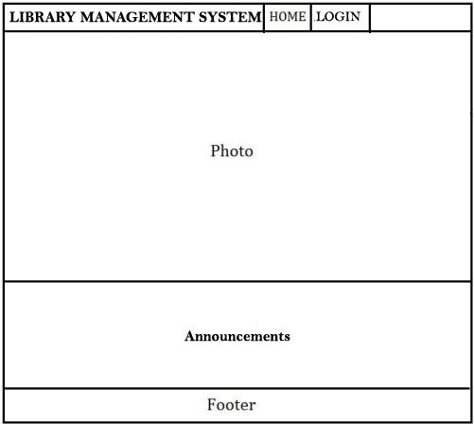

Figure 5: Initial Layout of First Screen layout

Figure 6 Home Page including Login option layout

This page is displayed while the website is firstly opened. the contains the Name of application, Home page & Login option.

20

Padam-Gurung(17031979)

FYP PROJECT: LIBRARY MANAGEMENT SYSTEM 05/08/2019

Login Screen Layout:
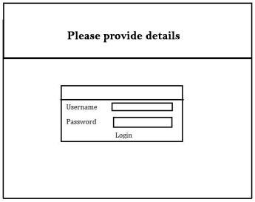

Figure 7 Login Screen Layout

The Login page contains two text fields to enter username & password to login as admin or as student. Only registered members can login further in the system.

21

Padam-Gurung(17031979)

FYP PROJECT: LIBRARY MANAGEMENT SYSTEM 05/08/2019

Admin Dashboard Layout:
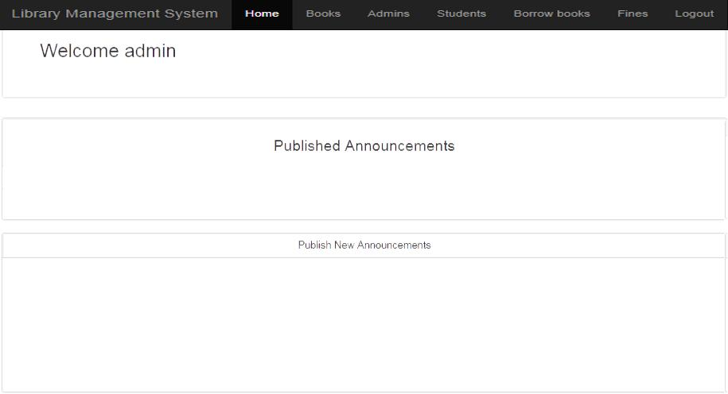

Figure 8 Admin Dashboard Layout

This is the Admin Dashboard displayed only by the admin login to the system. the contains the Home page of admin dashboard & options like Add Book, Add Admin, Add Student, View Borrowed Books, Stop Counting Fines & Logout.

22

Padam-Gurung(17031979)

FYP PROJECT: LIBRARY MANAGEMENT SYSTEM 05/08/2019

Student Dashboard Layout :
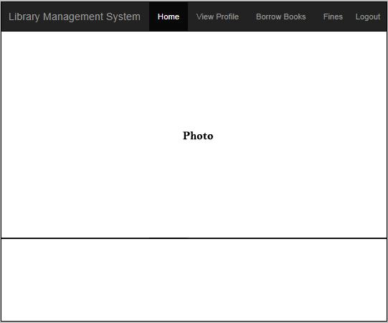

Figure 9 Student Dashboard Layout

This is the Student Dashboard displayed when the registered student member login to the system. the contains the Home page of student dashboard & options like View Profile, Borrow Books, Check Fines Status & Logout.

23

Padam-Gurung(17031979)

FYP PROJECT: LIBRARY MANAGEMENT SYSTEM 05/08/2019

4.1.2 Final Wireframe Design:

4.2 UI Design:

4.2.1 UI Design Of Home Page including Login option:
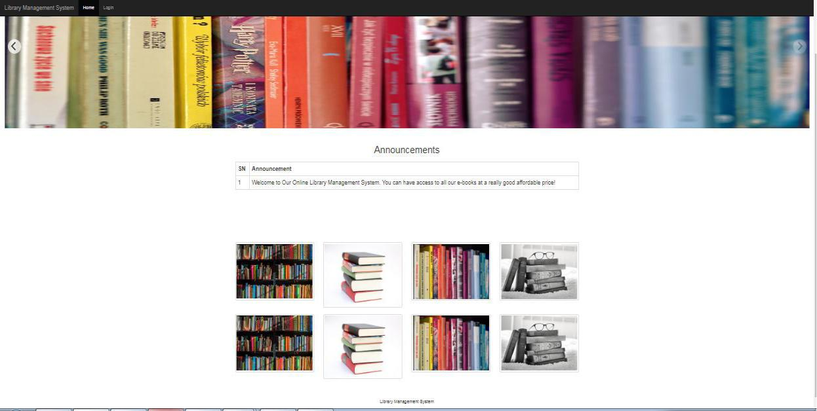

Figure 10: UI Design Of Home Page including Login option

24

Padam-Gurung(17031979)

FYP PROJECT: LIBRARY MANAGEMENT SYSTEM 05/08/2019

4.2.2 UI Design Of Login Screen:
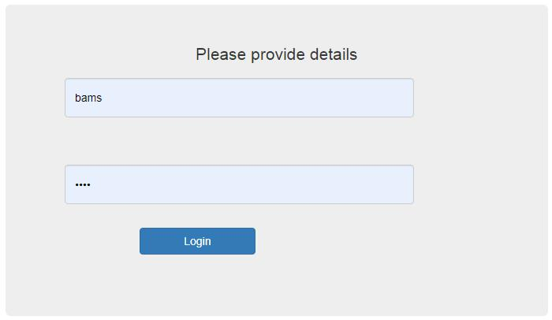

Figure 11: UI Design Of Login Screen

4.2.3 UI Design Of Admin Dashboard
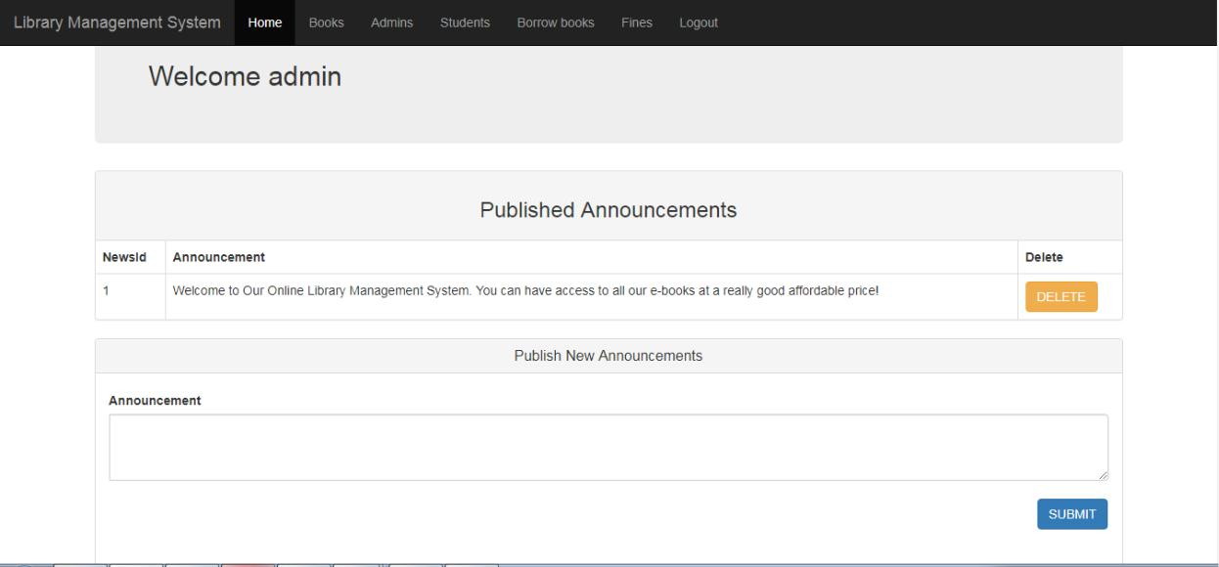

Figure 12 UI Design Of Admin Dashboard

25

Padam-Gurung(17031979)

FYP PROJECT: LIBRARY MANAGEMENT SYSTEM 05/08/2019

4.2.4 UI Design Of Student Dashboard
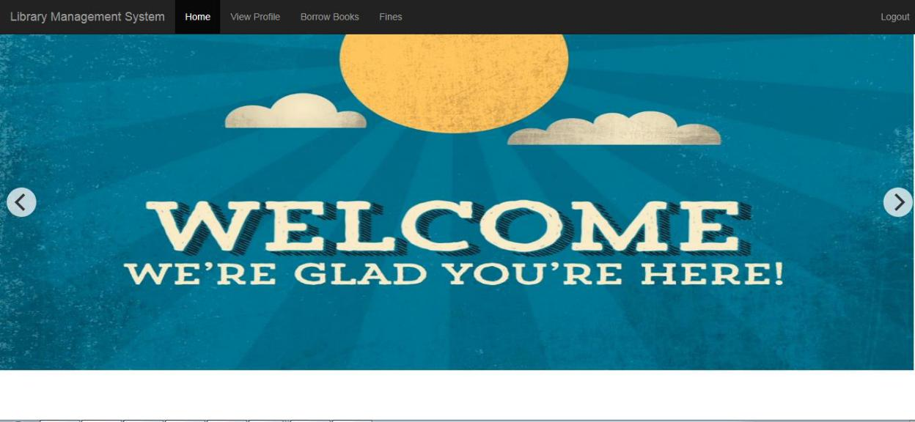

Figure 13 UI Design Of Student Dashboard

26

Padam-Gurung(17031979)

FYP PROJECT: LIBRARY MANAGEMENT SYSTEM 05/08/2019

4.3 System Architecture:

Administrators:

Administrators are the users at highest level of authentication. They are provided with all authentication & full control of the content management. They can add, delete & update the books, member & dynamic information in the system. They can issue books to the members & should keep the records of returned books.

Admin System Architecture
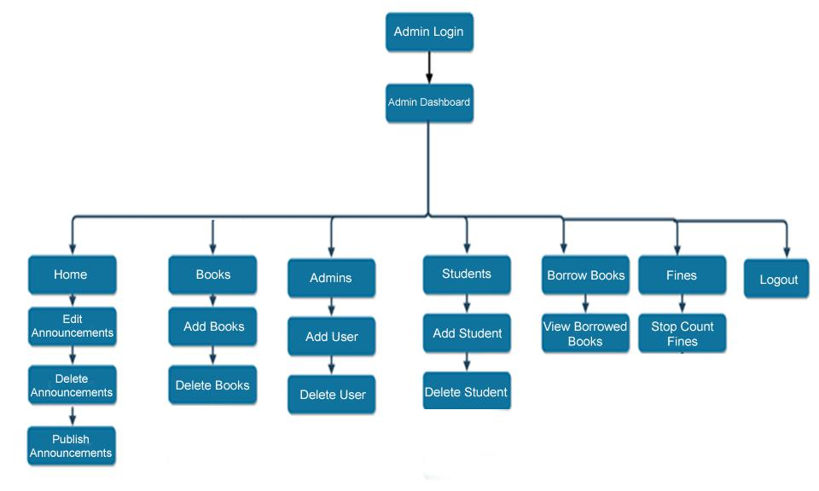

Figure 14 Admin System Architecture

27

Padam-Gurung(17031979)

FYP PROJECT: LIBRARY MANAGEMENT SYSTEM 05/08/2019

Members

Members are provided more access to share their queries through the system to the particular person who will be authorized as the admin of the system. They can had the facilities of borrowing the available books of library, editing their membership information with the help of admin & returning the books within the deadline. Such user should pay late fee if they are unable to return books on time.

Members System Architecture
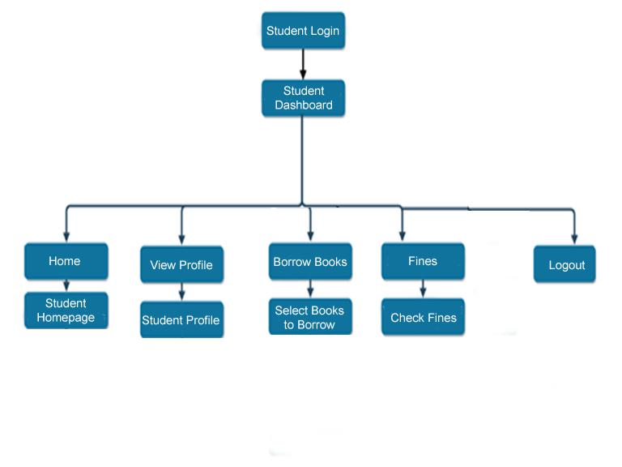

Figure 15 Members System Architecture

28

Padam-Gurung(17031979)

FYP PROJECT: LIBRARY MANAGEMENT SYSTEM 05/08/2019

4.4 Use Case Diagram:

Use case diagram is graphical representation of the interactions among the elements of system. It is methodology used in system analysis for identifying, clarifying, & organizing system requirements. Use case diagram contains actors systems & goals.

- Actors: The Actors could be anyone who interacts with the system. Actor can be person, organization or anybody outside the system who utilizes information or services of system. Symbol of the actor in use case diagram is person.

- System: System is like scenario with which actors interact to perform certain task.

- Goals: Goals represents end result of task that actor tries to gain by interacting with system.

29

Padam-Gurung(17031979)

FYP PROJECT: LIBRARY MANAGEMENT SYSTEM 05/08/2019

Use Case Diagram of Admin:
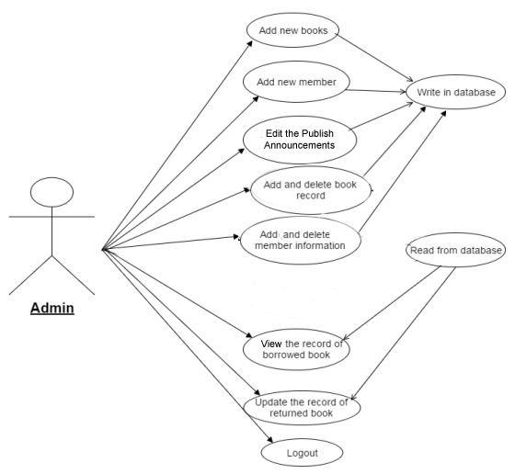

Figure 16 Use Case Diagram of Admin

30

Padam-Gurung(17031979)

FYP PROJECT: LIBRARY MANAGEMENT SYSTEM 05/08/2019

Use Case Diagram of Member:
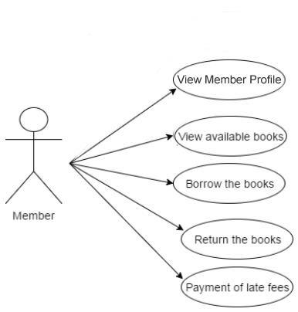

Figure 17 Use Case Diagram of Member

31

Padam-Gurung(17031979)

FYP PROJECT: LIBRARY MANAGEMENT SYSTEM 05/08/2019

4.5 Class Diagram:

Class diagram is static diagram. It represents static view of application. Class diagram is not only used for describing, visualizing & documenting different aspects of system but also for constructing executable code of software application .Class diagram of Library Management System is below:
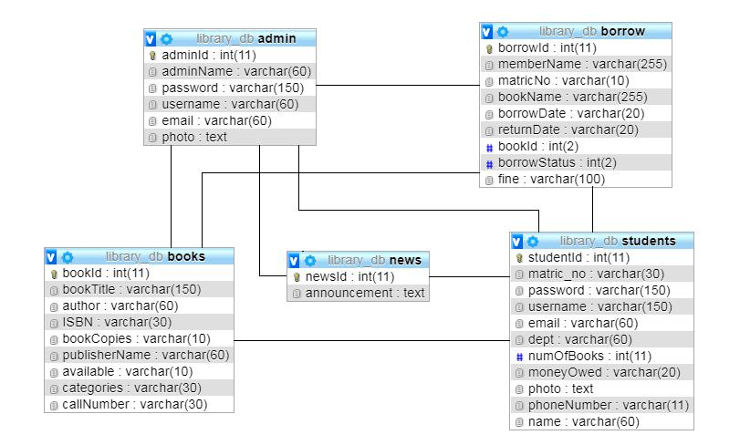

Figure 18: Class Diagram of LIBRARY MANAGEMENT SYSTEM.

4.6 Entity Relationship ( ER ) Diagram:

Entity Relationship Diagram, also known as ERD, ER Diagram or ER model, is type of structural diagram for use in database design. ERD contains different symbols & connectors that visualize two important information: major entities with system scope, & inter-relationships among entities. ER diagram Library Management System is below:

32

Padam-Gurung(17031979)

FYP PROJECT: LIBRARY MANAGEMENT SYSTEM 05/08/2019
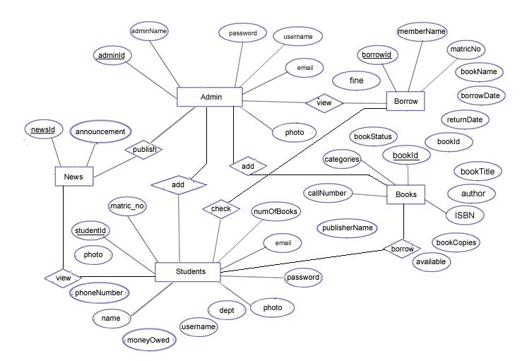

Figure 19: Entity Relationship Diagram of LIBRARY MANAGEMENT SYSTEM.

33

Padam-Gurung(17031979)

FYP PROJECT: LIBRARY MANAGEMENT SYSTEM 05/08/2019

Chapter 5: Implementation:

Implementation is stage of prototype that begins after completion of designing phase of development process. After successful collection of requirements of functional & non-functional requirements for system by conducting surveys, UML diagram of each layout for system was developed. the simplified work for developer to develop system.
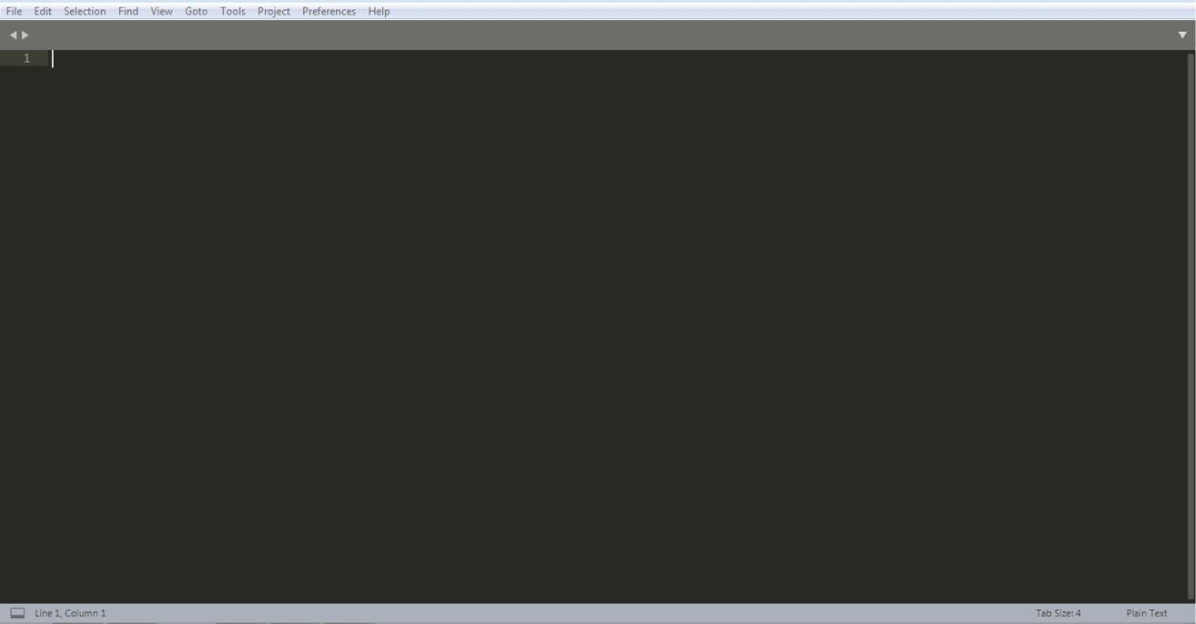

Figure 20 Startup of Sublime Text Editor

As my project is web-based system, so for the coding & development of my project I had selected Sublime Text Editor as it provides lot of features for development web based system. Sublime Text 3 version is used for development of the system. At present Sublime Text Editor is a most popular web applications developing software.

34

Padam-Gurung(17031979)

FYP PROJECT: LIBRARY MANAGEMENT SYSTEM 05/08/2019
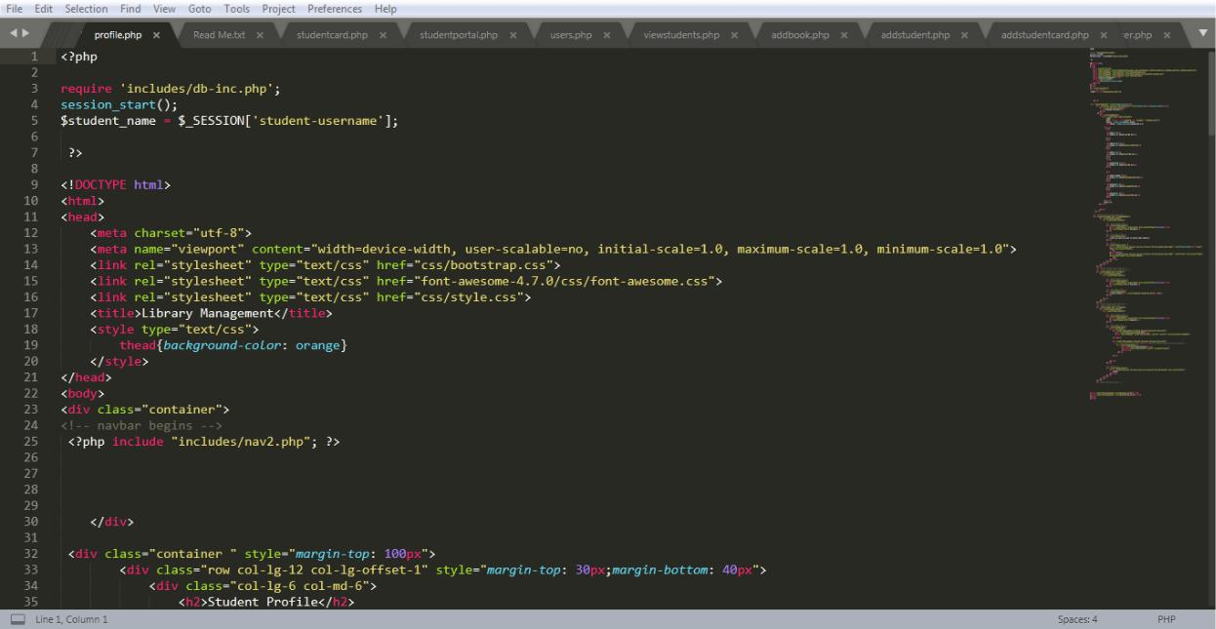

Figure 21: Coding of Library Management System in Sublime

Database Screen Shots:
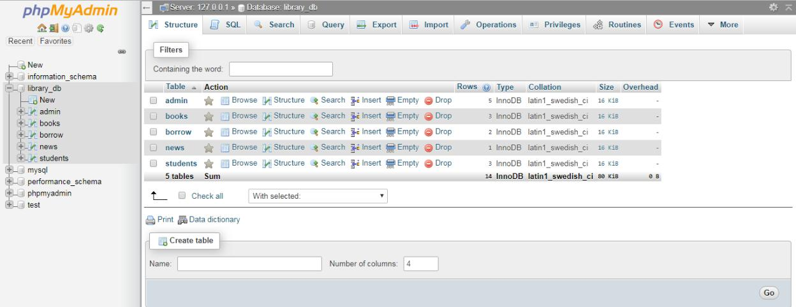

Figure 22: Database Of My Project

35

Padam-Gurung(17031979)

FYP PROJECT: LIBRARY MANAGEMENT SYSTEM 05/08/2019
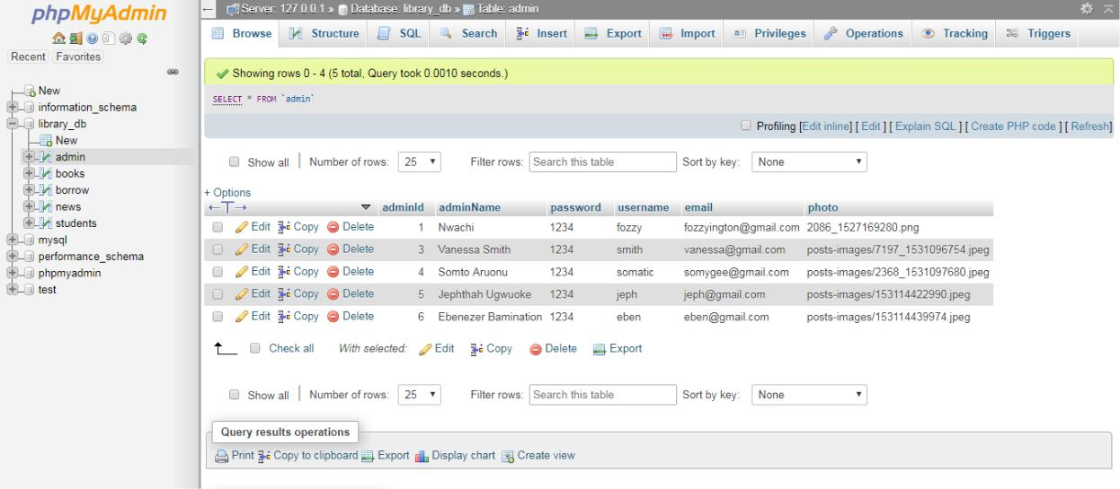

Figure 23: Database of Admin
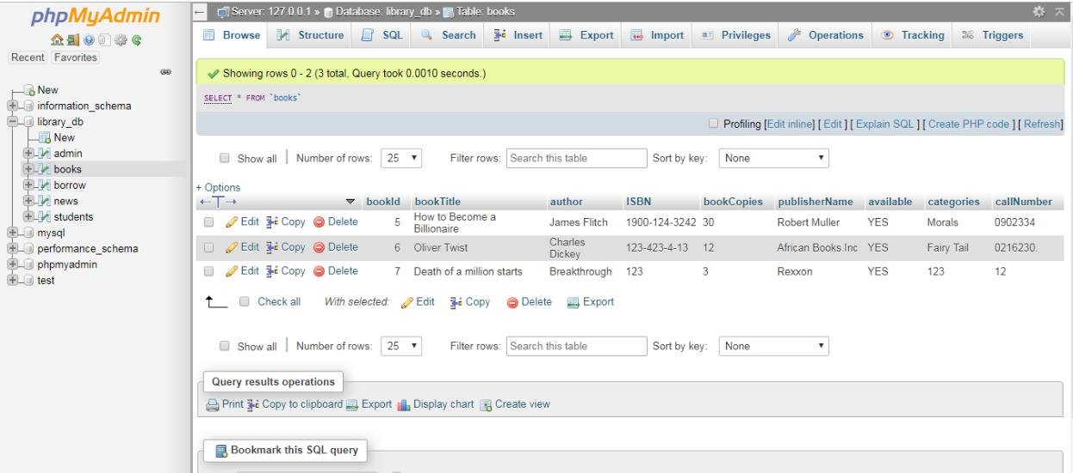

Figure 24: Database of books

36

Padam-Gurung(17031979)

FYP PROJECT: LIBRARY MANAGEMENT SYSTEM 05/08/2019
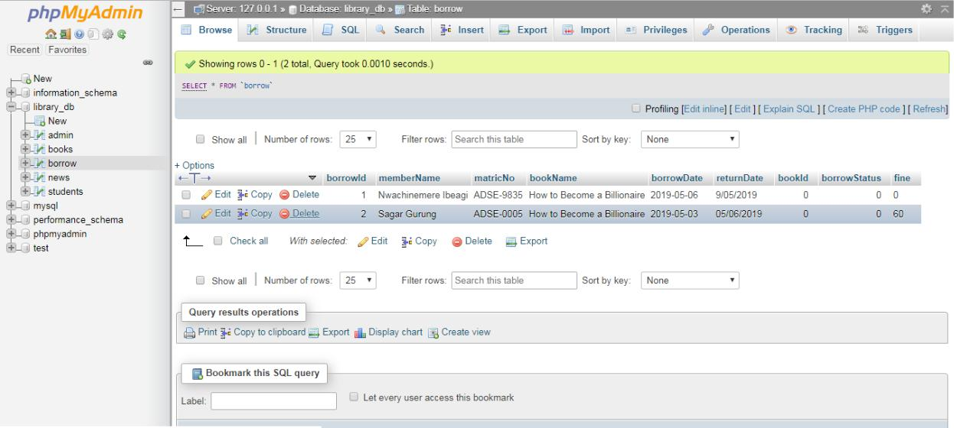

Figure 25 Database of Borrow Books
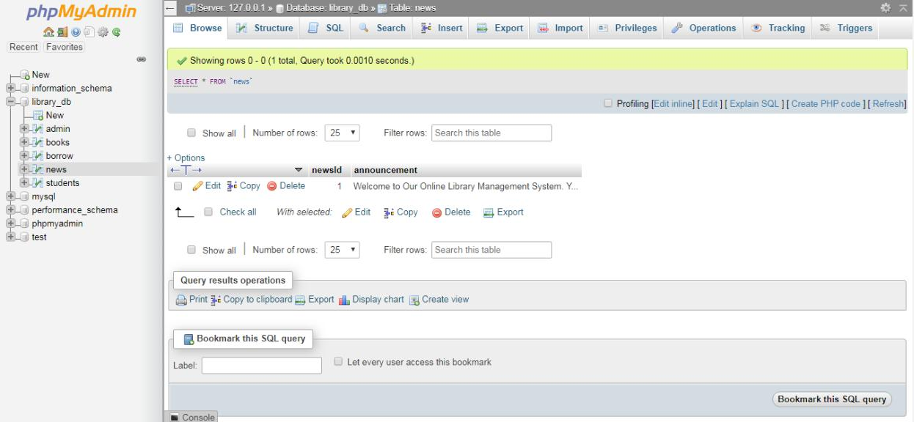

Figure 26 Database of Announcement News

37

Padam-Gurung(17031979)

FYP PROJECT: LIBRARY MANAGEMENT SYSTEM 05/08/2019
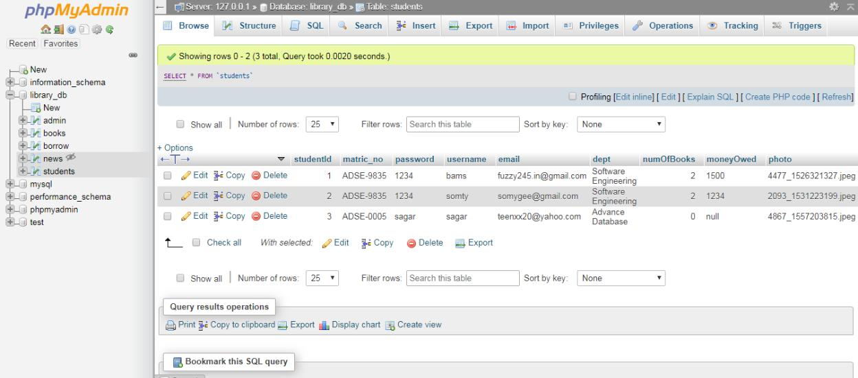

Figure 27 Database of Students

38

Padam-Gurung(17031979)

FYP PROJECT: LIBRARY MANAGEMENT SYSTEM | 05/08/2019

Screen Shots of Project:

1. Home Page:
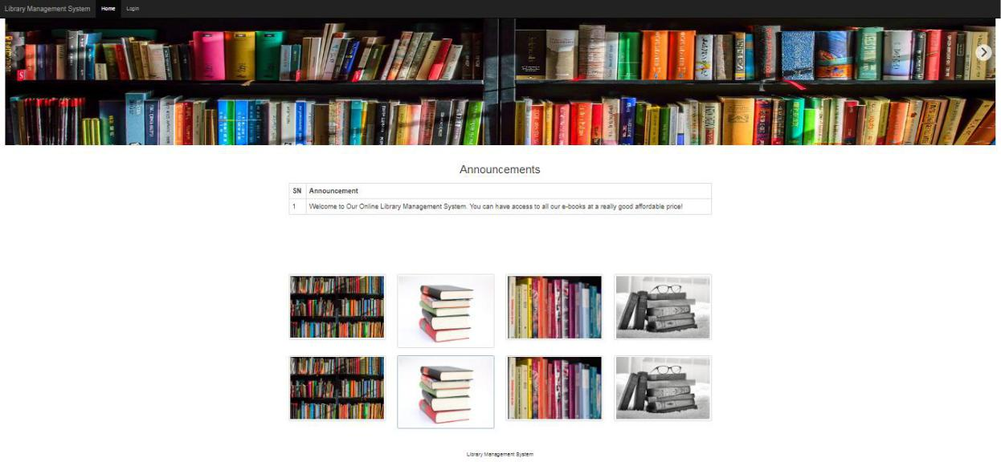

Figure 28: Home Page

2. Login Screen:
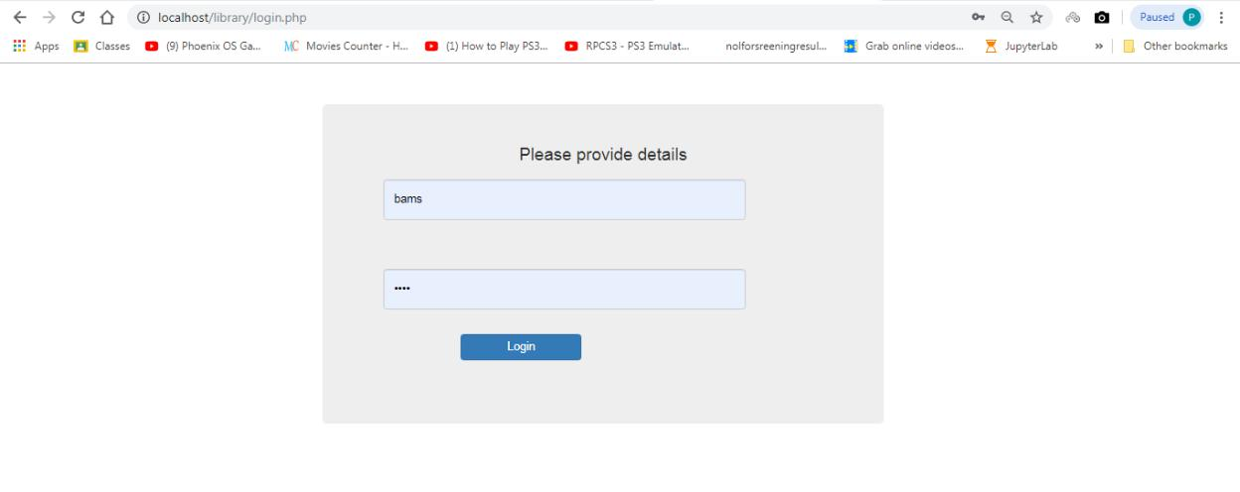

Figure 29: Login Screen

39

Padam-Gurung(17031979)
FYP PROJECT: LIBRARY MANAGEMENT SYSTEM | 05/08/2019

3. Admin Dashboard:
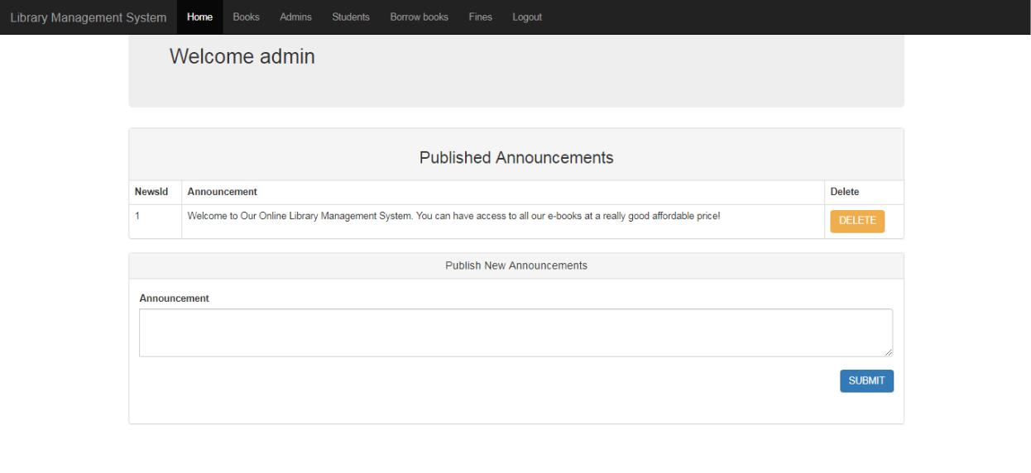

Figure 30: Admin Dashboard

4. Add Book Screen:
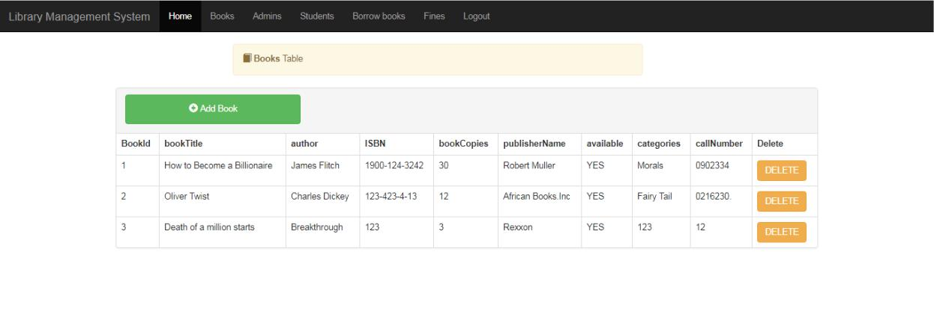

Figure 31: Add Book Screen

40

Padam-Gurung(17031979)
FYP PROJECT: LIBRARY MANAGEMENT SYSTEM 05/08/2019

5. Add Admin Screen:
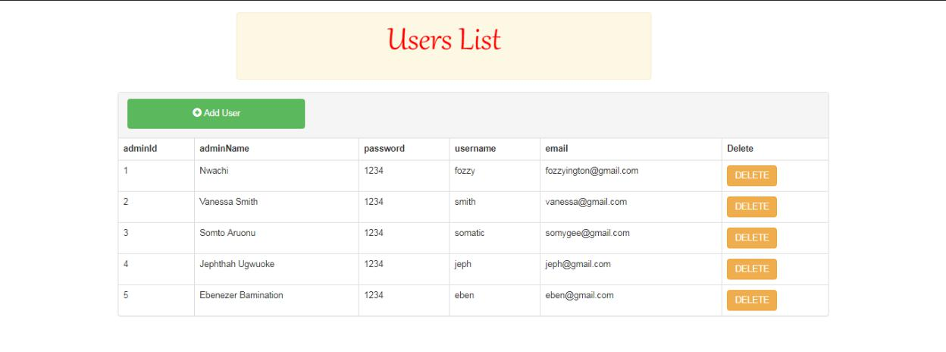

Figure 32: Add Admin Screen

6. Add Student Screen:
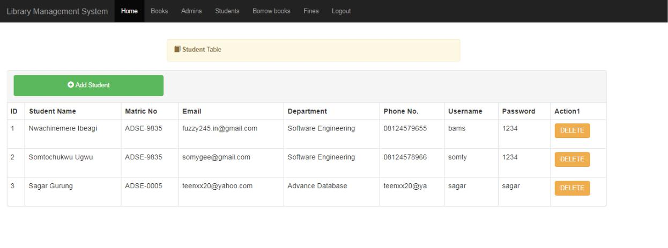

Figure 33: Add Student Screen

41

Padam-Gurung(17031979)

FYP PROJECT: LIBRARY MANAGEMENT SYSTEM | 05/08/2019

7. View Borrowed Books Screen
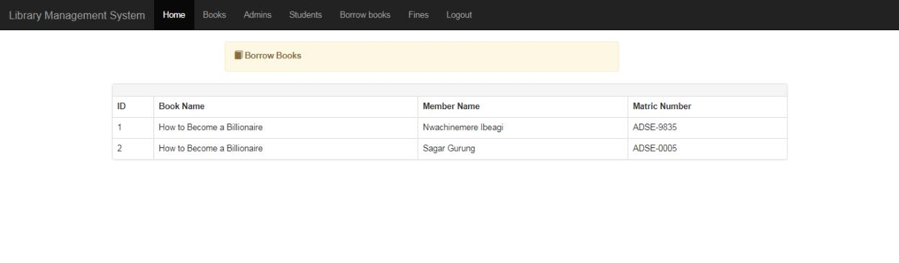

Figure 34 View Borrowed Books Screen

8. Stop Counting Fines Screen:
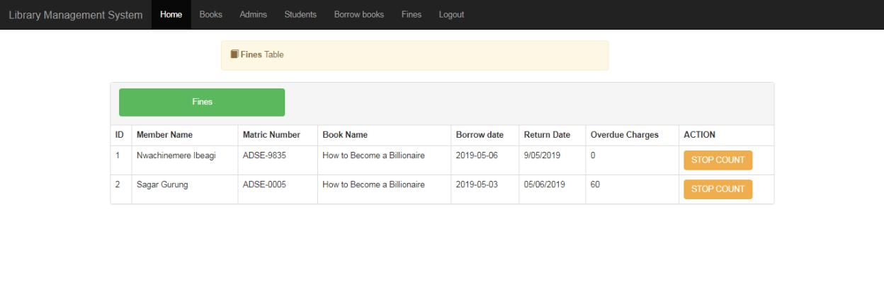

Figure 35: Stop Counting Fines Screen

42

Padam-Gurung(17031979)
FYP PROJECT: LIBRARY MANAGEMENT SYSTEM | 05/08/2019

9. Student Dashboard:
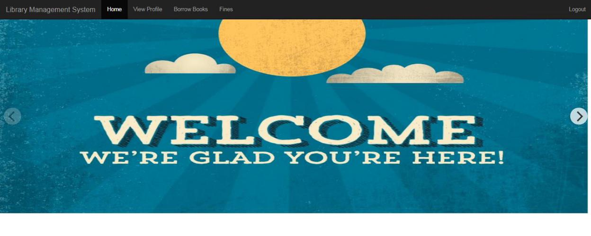

Figure 36 Student Dashboard

10. View Student Profile Screen
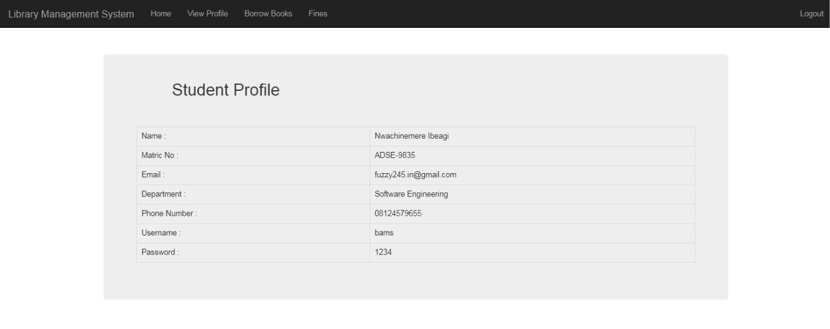

Figure 37 View Student Profile Screen

43

Padam-Gurung(17031979)
FYP PROJECT: LIBRARY MANAGEMENT SYSTEM | 05/08/2019

11. Borrow Books Screen:
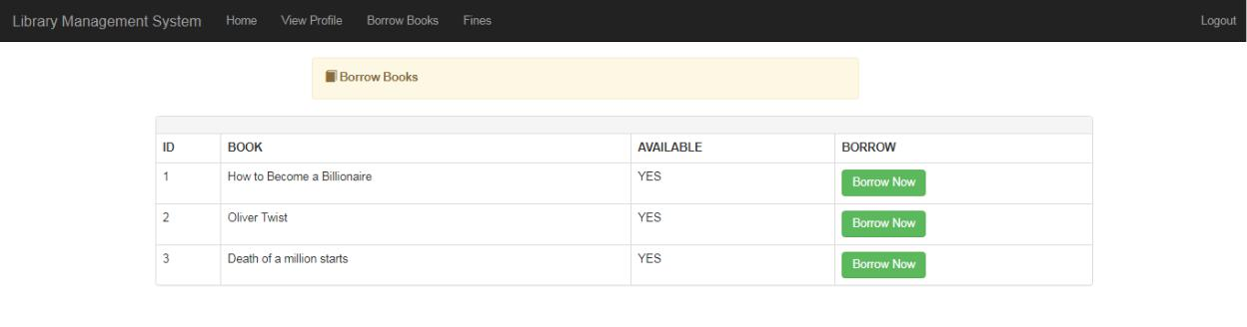

Figure 38 Borrow Books Screen

12. Check Fines Screen:
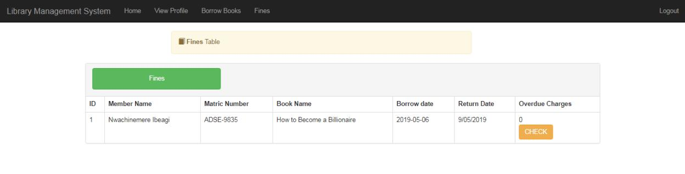

Figure 39 Check Fines Screen

44

Padam-Gurung(17031979)
FYP PROJECT: LIBRARY MANAGEMENT SYSTEM 05/08/2019

Chapter 6: Testing

Software testing is process, to evaluate functionality of software application with intent to find if developed software met specified requirements or not & to identify defects to ensure that product is defect free in order to produce quality product.

Software testing also helps to identify errors, gaps or missing requirements in contrary to actual requirements. It can be done manually or using automated tools. Some prefer saying Software testing as White Box & Black Box Testing.

In simple terms, Software Testing means Verification of Application Under Test.

Unit Testing

First of all, unit testing will be first testing method that used to test developed system. It consists of testing activities that test system module by module which has not been integrated as whole. By doing unit testing, developer are able to identify error & bug easily since it is finding error & bug through unit part of system than finding error through complete system. In addition, developer will test unit part of system with validation & correctness of data-value. Valid & invalid input will be entering to test & ensure system processes perform with expected result.

45

Padam-Gurung(17031979)

FYP PROJECT: LIBRARY MANAGEMENT SYSTEM | 05/08/2019

Unit Testing 1: Login as system user/student

Testing Objective: To be sure if user can login into system correctly with correct ID &password.

No | Event | Attribute & Value | Expected Result |  |  | Result
1 | Verify ID & password | Login ID: correctID | Login success. |  |  | Pass
 |  | Password:
 | enter by user & match with | correctPassword
 | data of database
 | when user click “Login”
 | button on login screen.
2 | Verify wrong ID & | Login ID: correctID | Login failed & |  |  | Pass
 |  | Password:
 | password that enter by user | wrongPassword | show error
 | & match with data | OR | message to user.
 | of database when user | Login ID: wrongID
 |  | Password:
 | click “Login” button on | correctPassword
 | login screen.
3 | Verify in situation that user | Login ID: empty | Login failed & |  |  | Pass
 | doesn't enter any value to
 | both username & password
 | when user click "Login” |  | show error
 | button on login screen. | Password: empty | message to user.

Unit Testing 2: Add new books

Testing Objective: To ensure new book can be added properly.

No | Event | Attribute & Value |  | Expected Result |  | Result
 |  | Complete | book
1 | Add new book. | information. |  | New book |  | Pass
 |  |  |  | added
 |  |  |  | successfully.
2 | Add new book | All blank. |  | Show required field |  | Pass
 |  |  |  |  | 46

Padam-Gurung(17031979)
FYP PROJECT: LIBRARY MANAGEMENT SYSTEM | 05/08/2019

 | without entering any |  | error message.
 | information.
3 | Add new book that | System's book information | Show required field | Pass
 | has at least one or more | with some field | error message.
 | field blank. | blank.
4 | Delete existing book. | Delete existing | Successfully deleted | Pass
 |  | book details. Eg: Name: | book details.
 |  | Twist of Life.

Unit Testing 3: Add new system user

Testing Objective: To ensure new user can be added properly.

No | Event | Attribute & Value |  | Expected Result | Result
 |  | Complete System | user
1 | Add new system user. | information. |  | New user | Pass
 |  |  |  | added
 |  |  |  | successfully.
2 | Add new system user | All blank. |  | Show required field | Pass
 | without entering any |  |  | error message.
 | information.
3 | Add new system user that | System's user information |  | Show required field | Pass
 | has at least one or more | with some field |  | error message.
 | field blank. | blank.
 | Delete existing system
4 | user. | Delete existing system's |  | Successfully deleted | Pass
 |  | user details. Eg: | Name: | System's user details.
 |  | Vanessa Smith

47

Padam-Gurung(17031979)
FYP PROJECT: LIBRARY MANAGEMENT SYSTEM |  |  |  |  | 05/08/2019
 | Unit Testing 4: Add new student member
 | Testing Objective: To ensure new member can be added properly.
 | No | Event | Attribute & Value | Expected Result |  |  | Result
 |  |  | Complete student member
 | 1 | Add new student member. | information. | New member |  |  | Pass
 |  |  |  | added
 |  |  |  | successfully.
 | 2 | Add new student member | All blank. | Show required field |  |  | Pass
 |  | without entering any |  | error message.
 |  | information.
 |  | Add new student member | System's
 | 3 | that | member information | Show required field |  |  | Pass
 |  | has at least one or more | with some field | error message.
 |  | field blank. | blank.
 |  | Delete existing student
 | 4 | member. | Delete existing student's | Successfully deleted |  |  | Pass
 |  |  | user details. Eg: Name: | details.^{System's} | member
 |  |  | Sam Smith

48

Padam-Gurung(17031979)
FYP PROJECT: LIBRARY MANAGEMENT SYSTEM 05/08/2019

Testing Plan

Test case no | Objective
1 | To check if user/member login validation works or not when
 | wrong details are provided.
2 | To check if Admin login works or not when correct details
 | provided.
3 | To check if Admin can publish new announcements or not.
4 | To check if Add Book works or not by Admin.
5 | To check if Delete Book works or not by Admin.
6 | To check if User registration work or not by Admin.
7 | To check if Delete User works or not by Admin.
8 | To check if Member registration work or not by Admin.
9 | To check if Delete Member works or not by Admin.
10 | To check if Admin can view borrowed books or not.

49

Padam-Gurung(17031979)

FYP PROJECT: LIBRARY MANAGEMENT SYSTEM 05/08/2019

11 | To check if Admin can stop counting fines on returned books or
 | not.
12 | To check logout function of Admin.
13 | To check if Member login works or not when correct details
 | provided.
14 | To check if Member can view his/her profile or not.
15 | To check if Member can borrow books or not.
16 | To check if member can check fines on overdue charges or not.
17 | To check logout function of Member.

50

Padam-Gurung(17031979)

FYP PROJECT: LIBRARY MANAGEMENT SYSTEM 05/08/2019

Test Cases:

 | Test Case 1
Test Case No.: | 1
Objective: | To check if user/member login validation works or
 | not when wrong details are provided.
Input | Wrong Details
Desired Output: | A message that says
 | ‘Login Failed. Please check your Details'.
Actual Output: | User/Member alerted with the message saying to
 | provide a valid email
Comments: | Test case succeeded.
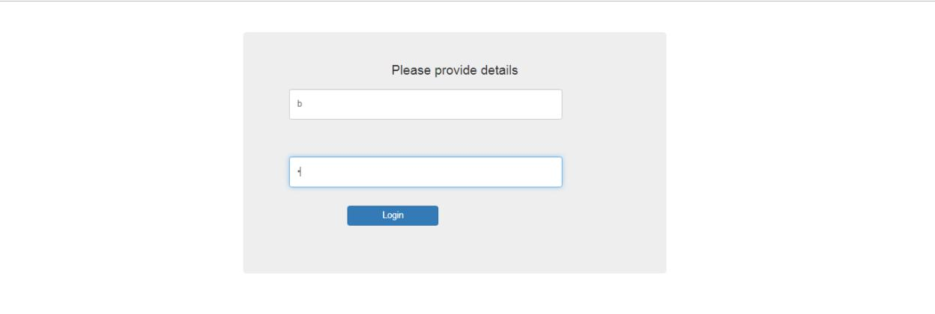

Figure 40 Test Case 1 Before

51

Padam-Gurung(17031979)

FYP PROJECT: LIBRARY MANAGEMENT SYSTEM 05/08/2019
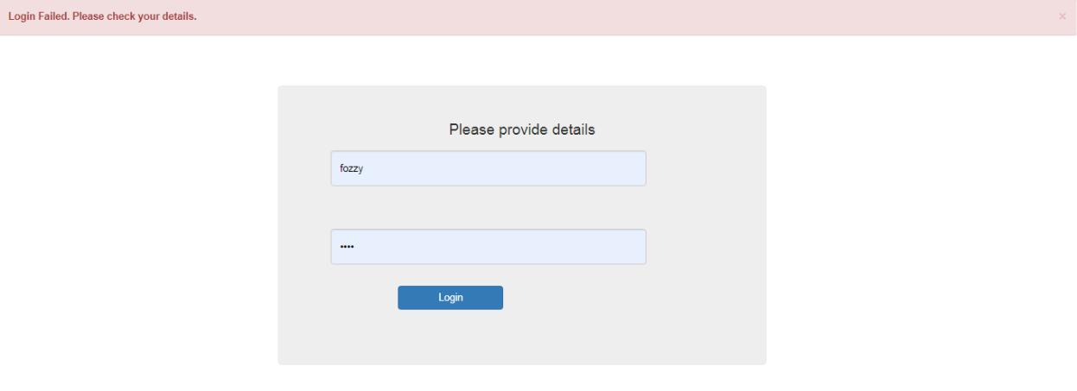

 |  | Figure 41 Test Case 1: After
Test Case 2
 | Test Case No.: | 2
 | Objective: | To check if Admin login works or not when correct
 |  | details provided.
 | Input | Correct details of Admin.
 | Desired Output: | Admin dashboard should be displayed.
 | Actual Output: | Admin dashboard displayed.
 | Comments: | Test case succeeded.
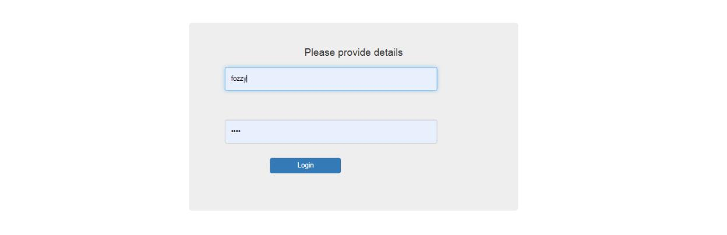

Figure 42 Test Case 2: Before

52

Padam-Gurung(17031979)

FYP PROJECT: LIBRARY MANAGEMENT SYSTEM 05/08/2019
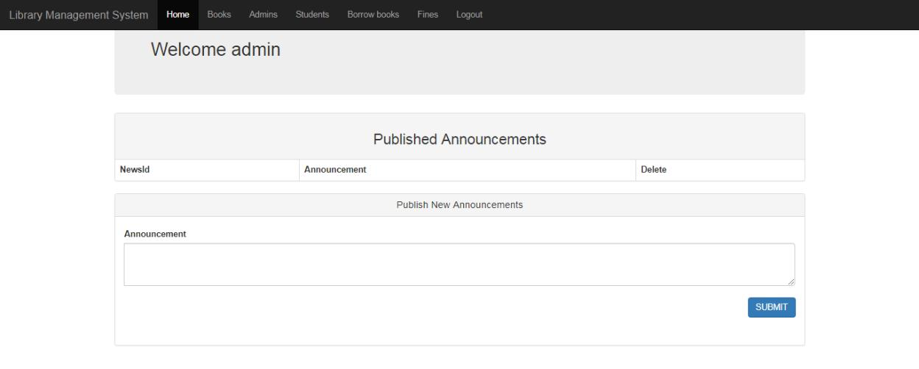

 |  | Figure 43 Test Case 2: After
Test Case 3
 | Test Case No.: | 3
 | Objective: | To check if Admin can publish new announcements
 |  | or not.
 | Input | Announcements.
 | Desired Output: | Announcements should be displayed.
 | Actual Output: | Announcements displayed.
 | Comments: | Test case succeeded.

53

Padam-Gurung(17031979)

FYP PROJECT: LIBRARY MANAGEMENT SYSTEM 05/08/2019
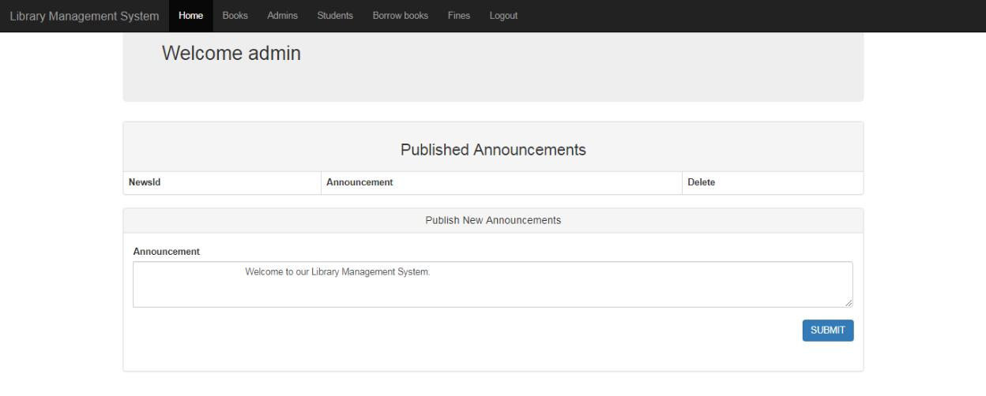

Figure 44 Test Case 3: Before
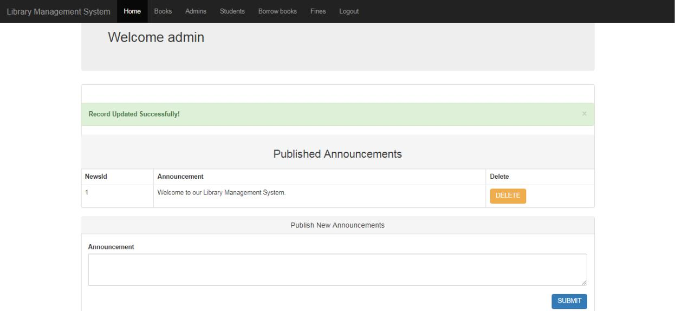

 |  | Figure 45 Test Case 3: After
Test Case 4
 | Test Case No.: | 4
 | Objective: | To check if Add Book works or not by Admin.
 | Input | Book details.
 |  | 54

Padam-Gurung(17031979)

FYP PROJECT: LIBRARY MANAGEMENT SYSTEM 05/08/2019

Desired Output: Book details should be added in the system.

Actual Output: Book details added in the system.

Comments: | Test case succeeded.

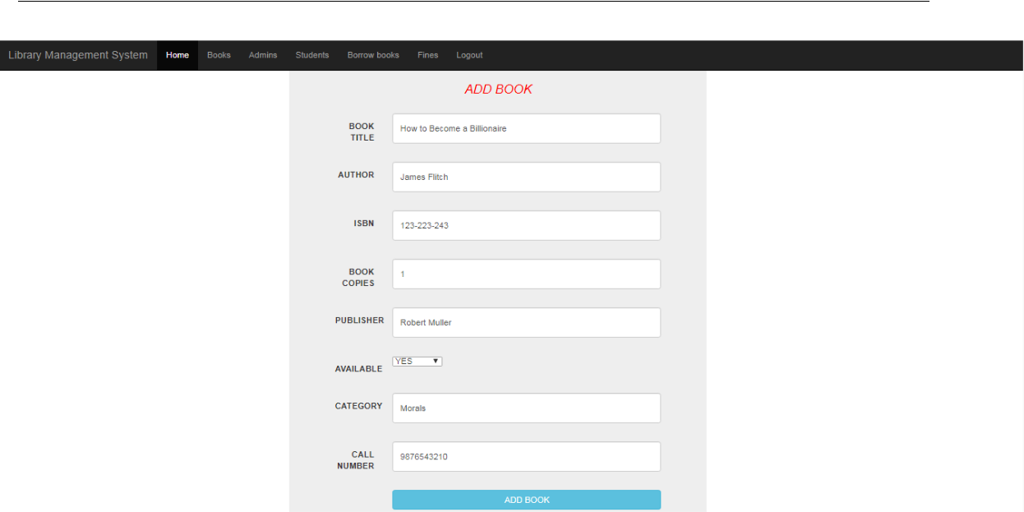

Figure 46 Test Case 4: Before
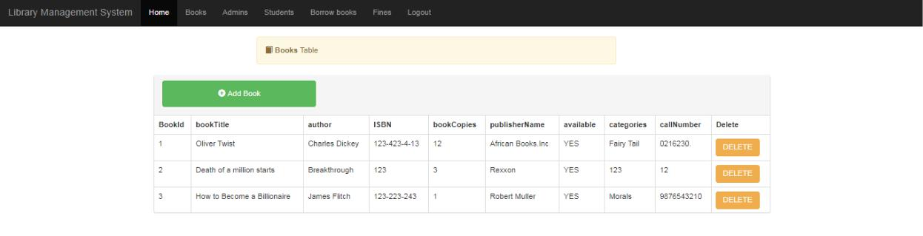

Figure 47 Test Case 4: After

55

Padam-Gurung(17031979)

FYP PROJECT: LIBRARY MANAGEMENT SYSTEM 05/08/2019

Test Case 5

Test Case No.: | 5
Objective: | To check if Delete Book works or not by Admin.
Input | Select a book & press Delete located on right side
 | of selected book.
Desired Output: | Selected book should be deleted.
Actual Output: | Selected book deleted.
Comments: | Test case succeeded.

Figure 48 Test Case 5: Before
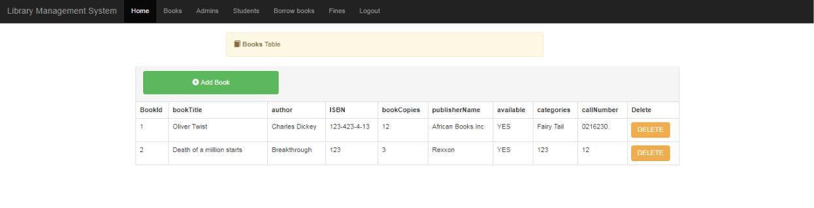

Figure 49 Test Case 5:After

56

Padam-Gurung(17031979)

FYP PROJECT: LIBRARY MANAGEMENT SYSTEM 05/08/2019

Test Case 6

Test Case No.: | 6
Objective: | To check if User registration work or not by Admin.
Input | User details.
Desired Output: | User should be registered.
Actual Output: | User registered.
Comments: | Test case succeeded.
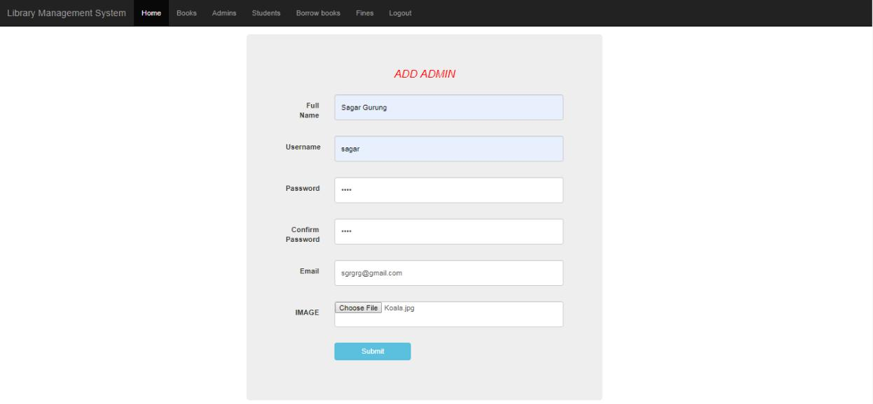

Figure 50 Test Case 6: Before

57

Padam-Gurung(17031979)

FYP PROJECT: LIBRARY MANAGEMENT SYSTEM 05/08/2019
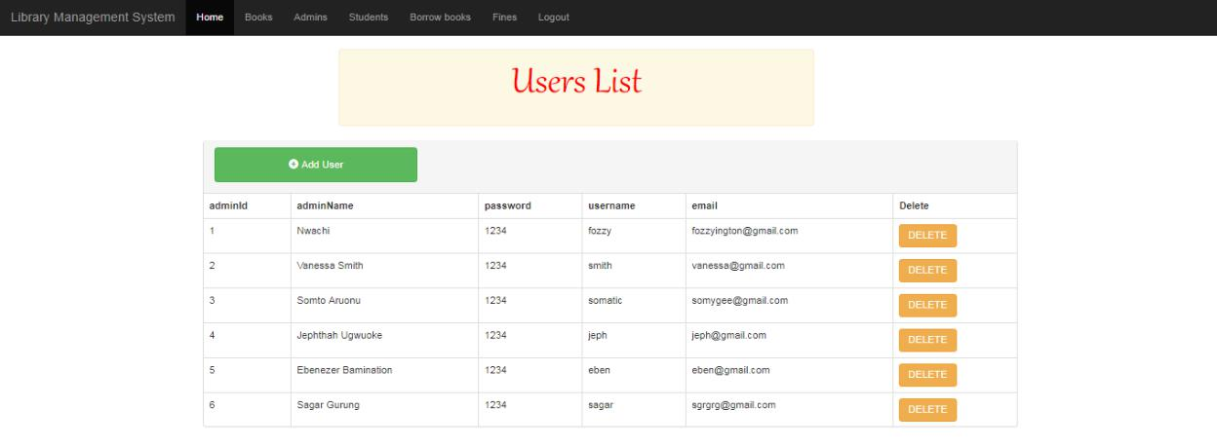

Figure 51 Test Case 6:After

Test Case 7

Test Case No.: | 7
Objective: | To check if Delete User works or not by Admin.
Input | Select a User & press Delete located on right side
 | of selected User.
Desired Output: | Selected User should be deleted.
Actual Output: | Selected User deleted.
Comments: | Test case succeeded.

58

Padam-Gurung(17031979)

FYP PROJECT: LIBRARY MANAGEMENT SYSTEM 05/08/2019
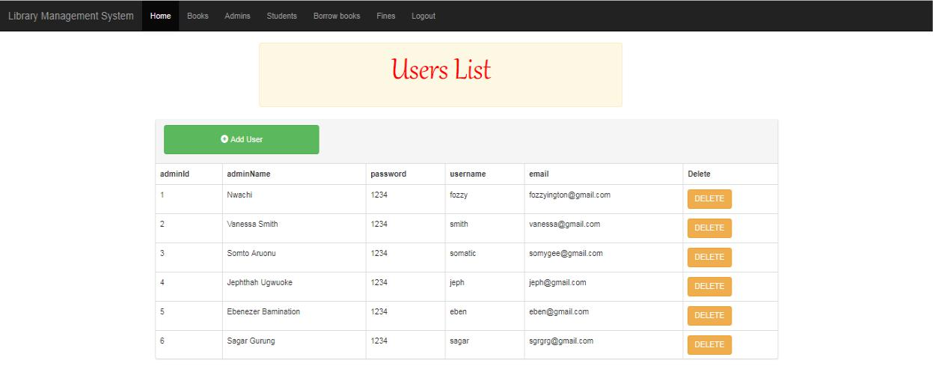

Figure 52 Test Case 7: Before
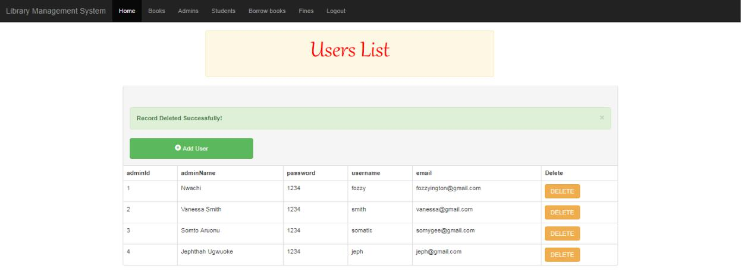

Figure 53 Test Case 7: After

59

Padam-Gurung(17031979)

FYP PROJECT: LIBRARY MANAGEMENT SYSTEM 05/08/2019

Test Case 8

Test Case No.: | 8
Objective: | To check if Member registration work or not by
 | Admin.
Input | Member details.
Desired Output: | Member should be registered.
Actual Output: | Member registered.
Comments: | Test case succeeded.
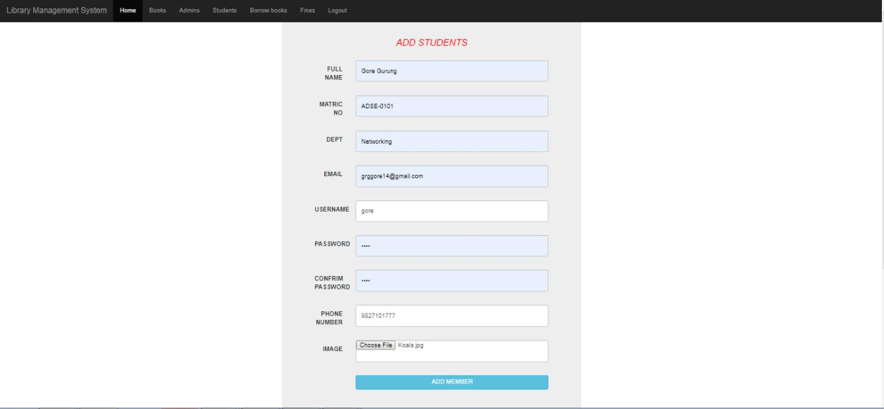

Figure 54 Test Case 8: Before
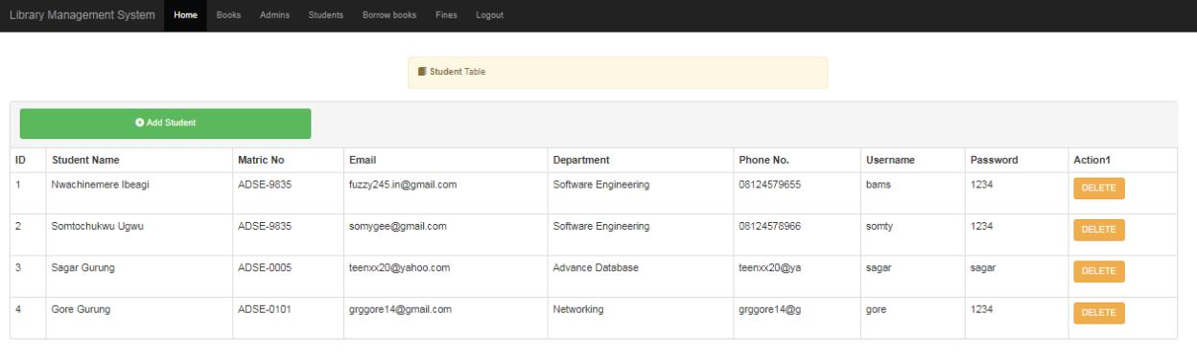

Figure 55 Test Case 8: After

60

Padam-Gurung(17031979)

FYP PROJECT: LIBRARY MANAGEMENT SYSTEM 05/08/2019

Test Case 9

Test Case No.: | 9
Objective: | To check if Delete Member works or not by Admin.
Input | Select a member and press Delete located on right
 | side of selected member.
Desired Output: | Selected member should be deleted.
Actual Output: | Selected member deleted.
Comments: | Test case succeeded.
Comments: | Test case succeeded.
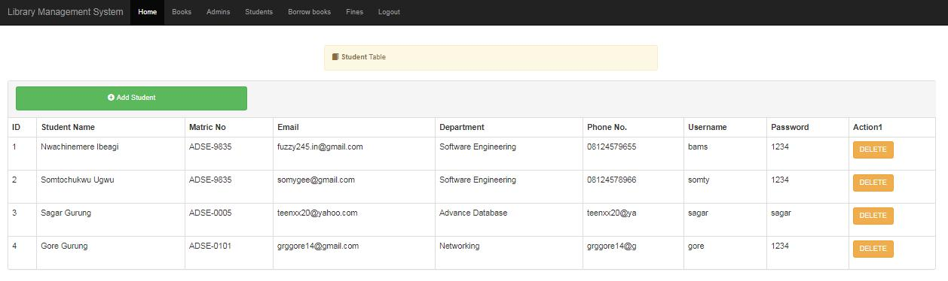

Figure 56 Test Case 9: Before

61

Padam-Gurung(17031979)

FYP PROJECT: LIBRARY MANAGEMENT SYSTEM 05/08/2019
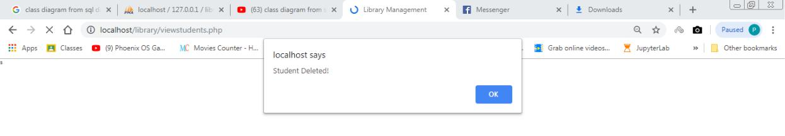
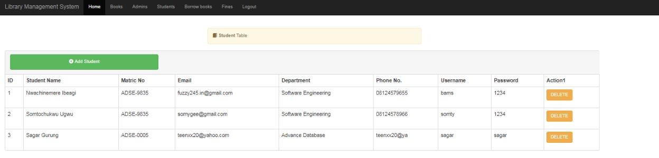

Figure 57 Test Case 9: After

Test Case 10

Test Case No.: | 10
Objective: | To check if Admin can view borrowed books or not.
Input | Click on Borrow books option on Admin dashboard.
Desired Output: | Borrowed books should be displayed.
Actual Output: | Borrowed books displayed.
Comments: | Test case succeeded.

62

Padam-Gurung(17031979)

FYP PROJECT: LIBRARY MANAGEMENT SYSTEM 05/08/2019
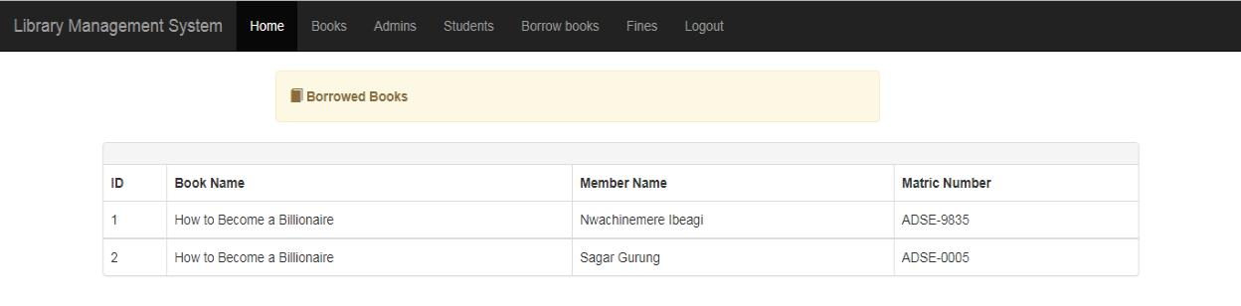

Figure 58 Figure 59 Test Case 10: After

Test Case 11

Test Case No.: | 11
Objective: | To check if Admin can stop counting fines on
 | returned books or not.
Input | Select a member and click on Stop Count located
 | on right side of selected member.
Desired Output: | Stop Count record should be updated.
Actual Output: | Stop Count record updated.
Comments: | Test case succeeded.
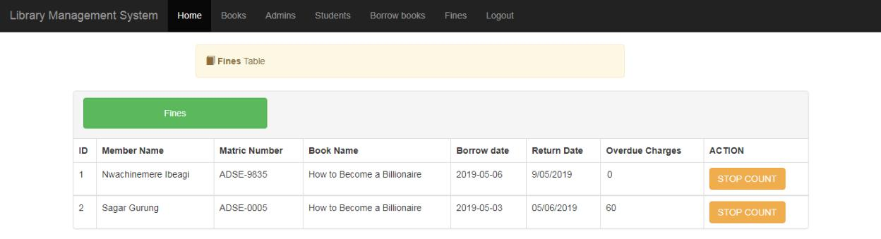

Figure 59 Test Case 11: Before

63

Padam-Gurung(17031979)

FYP PROJECT: LIBRARY MANAGEMENT SYSTEM 05/08/2019
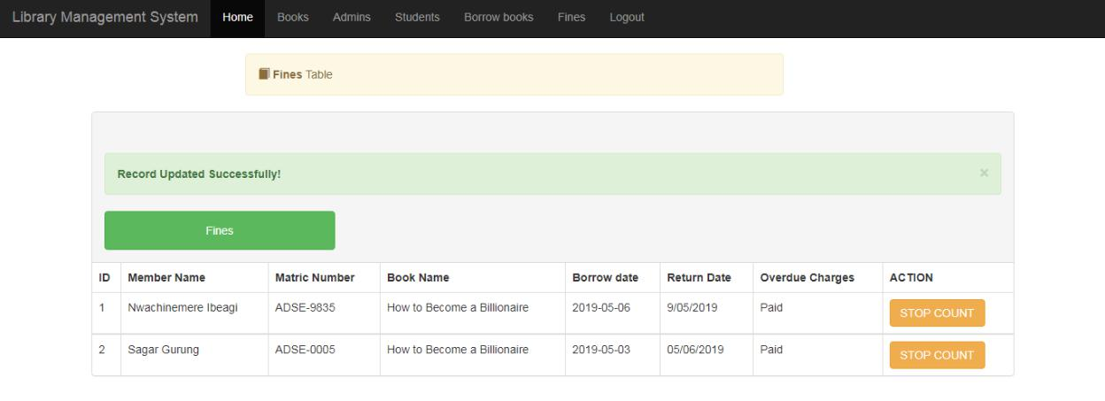

Figure 60 Test Case 11: After

Test Case 12

Test Case No.: | 12
Objective: | To check logout function of Admin.
Input | Click on logout option of Admin dashboard.
Desired Output: | Admin should be logout.
Actual Output: | Admin logout.
Comments: | Test case succeeded.

64

Padam-Gurung(17031979)

FYP PROJECT: LIBRARY MANAGEMENT SYSTEM 05/08/2019
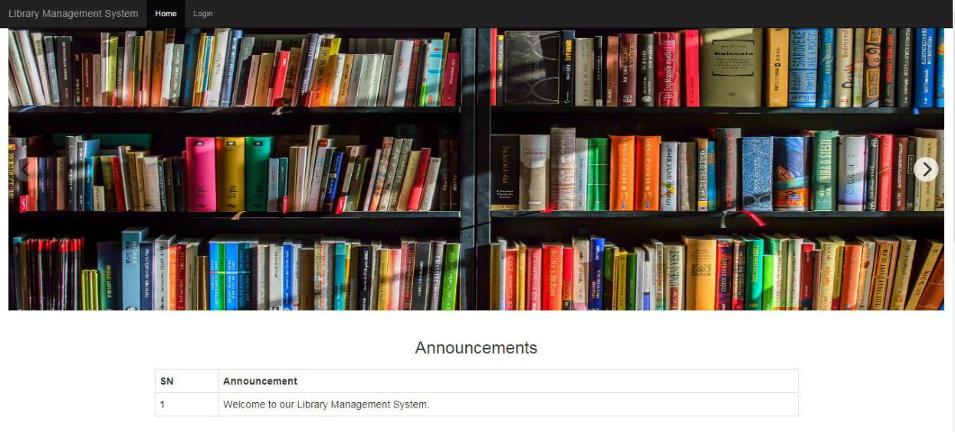

 |  | Figure 61 Test Case 12: After
Test Case 13
 | Test Case No.: | 13
 | Objective: | To check if Member login works or not when correct
 |  | details provided.
 | Input | Correct details of member.
 | Desired Output: | Member should be login to member dashboard.
 | Actual Output: | Member login to member dashboard.
 | Comments: | Test case succeeded.

65

Padam-Gurung(17031979)

FYP PROJECT: LIBRARY MANAGEMENT SYSTEM 05/08/2019
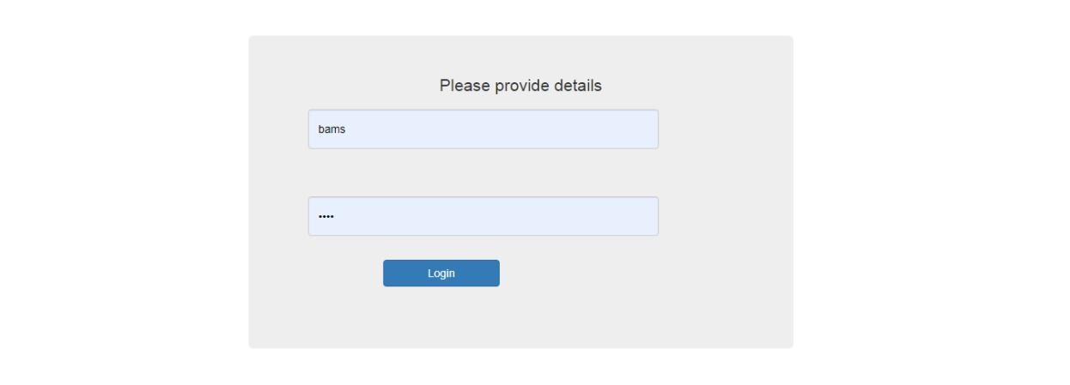

Figure 62 Taste Case 13: Before
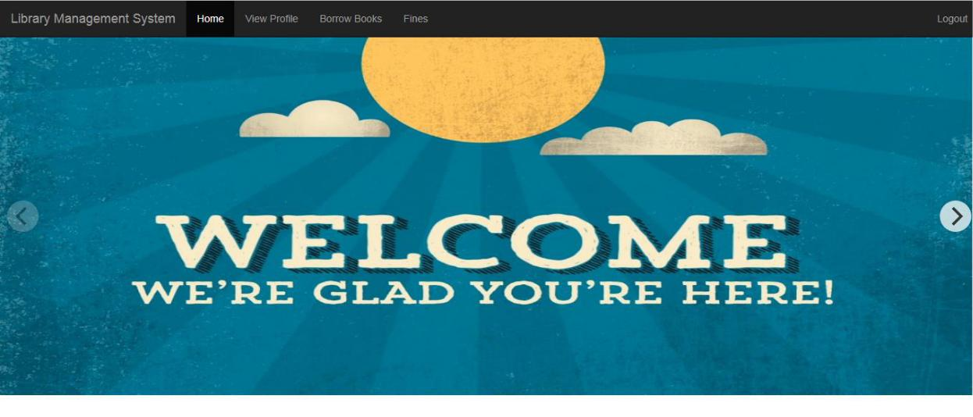

Figure 63 Taste Case 13: After

66

Padam-Gurung(17031979)

FYP PROJECT: LIBRARY MANAGEMENT SYSTEM 05/08/2019

Test Case 14

Test Case No.: | 14
Objective: | To check if Member can view his/her profile or not.
Input | Click on View Profile option of student dashboard.
Desired Output: | Student profile should be displayed.
Actual Output: | Student profile displayed.
Comments: | Test case succeeded.
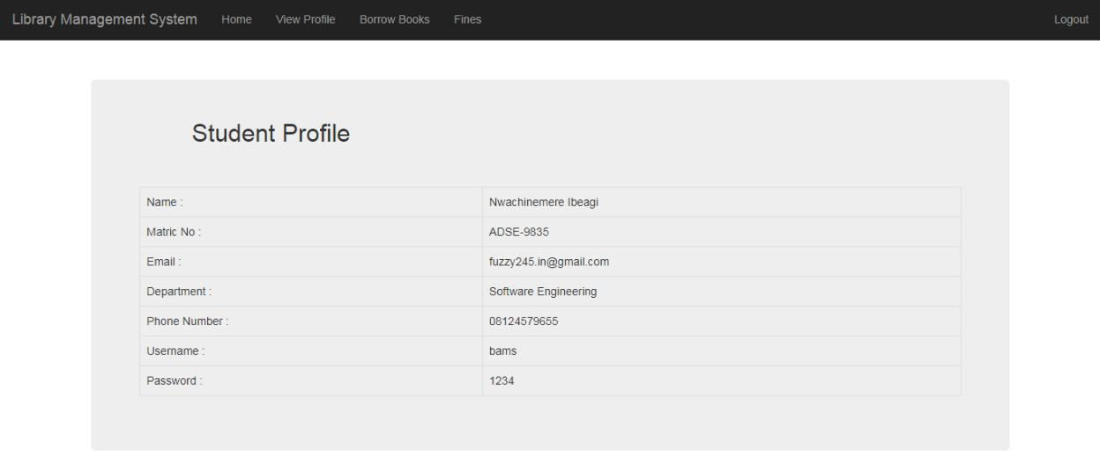

 |  |  | Figure 64 Test Case 14: After
Test Case 15
 | Test Case No.: |  | 15
 | Objective: |  | To check if Member can borrow books or not.
 | Input |  | Select a book and click on Borrow Now located on
 |  |  | right side of selected book.
 | Desired Output: |  | Member should be able to borrow available books.
 | Actual Output: |  | Member borrowed available books.
 | Comments: |  | Test case succeeded.
 |  |  | 67
Padam-Gurung(17031979)

FYP PROJECT: LIBRARY MANAGEMENT SYSTEM 05/08/2019
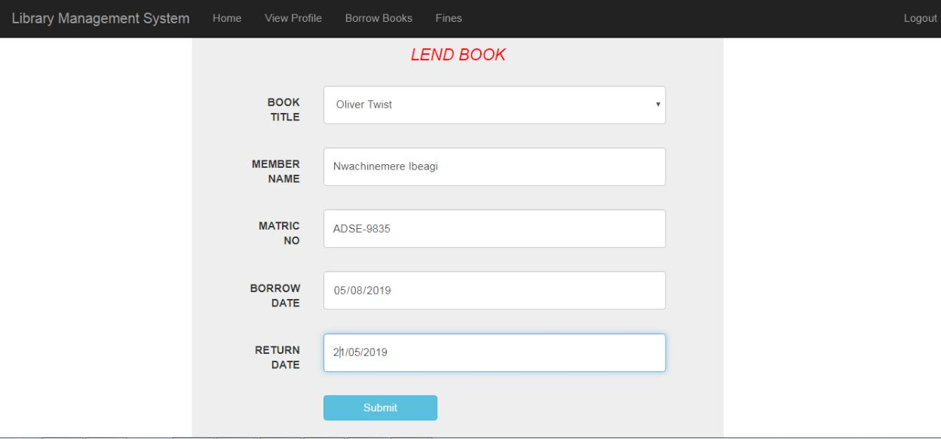

Figure 65 Test Case 15: Before
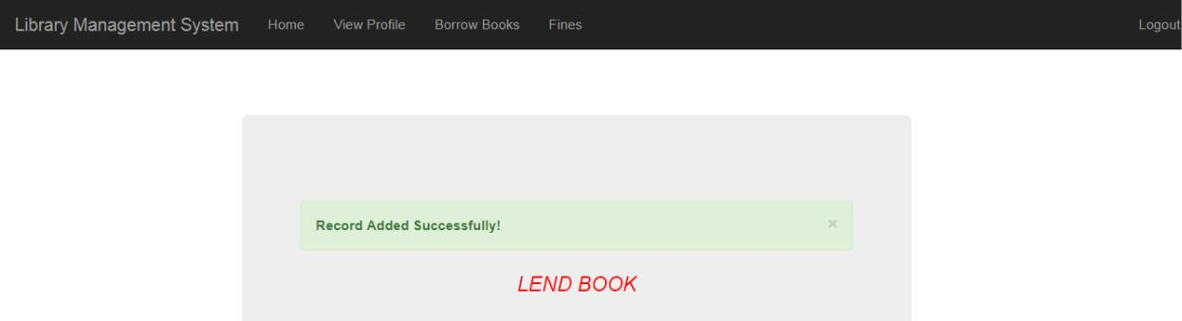

Figure 66 Test Case 15: After

68

Padam-Gurung(17031979)

FYP PROJECT: LIBRARY MANAGEMENT SYSTEM 05/08/2019

Test Case 16

Test Case No.: | 16
Objective: | To check if member can check fines on overdue
 | charges or not.
Input | Click on Check located on the right side of Fines
 | Table.
Desired Output: | Overdue charges should be checked.
Actual Output: | Overdue charges checked.
Comments: | Test case succeeded.
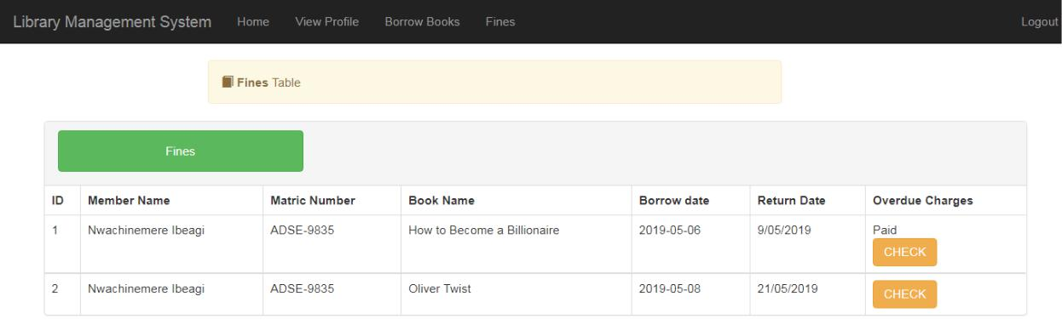

 |  | Figure 67 Test Case 16: After
Test Case 17
 | Test Case No.: | 17
 | Objective: | To check logout function of Member.
 | Input | Click on Logout option of Member dashboard.
 | Desired Output: | Member should be logout.
 | Actual Output: | Member logout.
 | Comments: | Test case succeeded.

69

Padam-Gurung(17031979)

FYP PROJECT: LIBRARY MANAGEMENT SYSTEM 05/08/2019

Figure 68 Test Case: 17 After

70

Padam-Gurung(17031979)

FYP PROJECT: LIBRARY MANAGEMENT SYSTEM 05/08/2019

Chapter 7: Evaluation of Testing

7.1 Evaluation done by the system users

After development of system, it was ready to use. So system (web application) was hosted on local host so we use system with no any problem. System was checked by some of my collides & they found impressive. They found my project nice for the proper management of Library-books.

7.2 Critical Evaluation

All time I had devoted to develop the system has helped me lot. I had got chances to learn UI designing & development. I had started out with little bit of my programming skills but now I had experienced more deeper in field of programming. With every step performing during development phase I got familiar with different logical skills & be implemented in another development section of project. After critical evaluation of whole project following Strengthens, Weakness, Opportunity & Threats are known.

7.2.1 Strengthens

- By to its easy & simple navigation user interface, it save a lot of time of user.

- Only User add books & save them, so it is safe & reliable.

- System be used at any time by the admin/member.

IV. Admin view & manage books, admins & members.

7.2.2 Weakness

- The website fine payment system is not online.

- Admin cannot edit existing admin, book or member data.

71

Padam-Gurung(17031979)

FYP PROJECT: LIBRARY MANAGEMENT SYSTEM 05/08/2019

7.2.3 Opportunity

- Can help to improve the Library Management System of Nepal.

- Helps to provide a Library Management platform for people of Nepal.

7.2.4 Scope

- Promotion of Schools/Colleges.

- Systematic and Easy Library Management System.

7.2.5 Limitation

- There is no sufficient information input fields.

- The security & privacy of information on website is not so good.

- People who are not registered cannot use the website.

72

Padam-Gurung(17031979)

FYP PROJECT: LIBRARY MANAGEMENT SYSTEM 05/08/2019

Chapter :9 Conclusion

The project has been completed with the successful accomplishment of most of the user requirement along with some limitations. By the help of similar project, survey & research I got many require knowledge about the Library Management System. With the necessary requirement, I had ideas to complete my project. I was able to complete my project by taking the ideas from the similar project.

The Library Management System of School is developed for library of an educational institute which helps to manage & keep record of borrowed & returned books. The entire user receive the full advantage from the Library Management System.

73

Padam-Gurung(17031979)

FYP PROJECT: LIBRARY MANAGEMENT SYSTEM 05/08/2019

References:

--Pdf Library Management System An Open Alternative Largepr ~ Ukashturka.

2019. Pdf Library Management System An Open Alternative Largepr ~ Ukashturka.

[ONLINE] | Available | at: | https://www.ukashturka.com/library-management-system-
project-report-pdf/pdf-library-management-system-an-open-alternative-largepr/ |  |  |  | .
[Accessed 7 May 2019].
--Naresh Koirala and Paul Bird. 2019. Library Development in Nepal: Problems and
prospects. |  |  | [ONLINE] | Available

at: https://nepallibrary.org/sites/default/files/Library%20Development%20in%20Nepal% 20-%20Problems%20and%20Prospects.pdf. [Accessed 7 May 2019].

--Project Topics. 2019. DESIGN AND IMPLEMENTATION OF A COMPUTERIZED LIBRARY MANAGEMENT SYSTEM - Project Topics. [ONLINE] Available at: https://www.projecttopics.org/design-implementation-computerized-library-management-system.html. [Accessed 7 May 2019].

--Attitudes and practices of Canadian academic librarians regarding library and online privacy: A national study - ScienceDirect. 2019. Attitudes and practices of Canadian academic librarians regarding library and online privacy: A national study -

ScienceDirect. |  | [ONLINE] |  | Available
at: | https://www.sciencedirect.com/science/article/abs/pii/S0740818817303638 |  | .
[Accessed 7 May 2019].

--Western Suffolk Boces. 2019. School Library System - Western Suffolk Boces. [ONLINE] Available at: http://www.wsboces.org/instructional-support-2/school-library-system/. [Accessed 7 May 2019].

--CodeCanyon. | 2019. library | management system by nazrul2013 | CodeCanyon.
[ONLINE] | Available | at: | https://codecanyon.net/item/library-management-
 |  | 74
Padam-Gurung(17031979)

FYP PROJECT: LIBRARY MANAGEMENT SYSTEM 05/08/2019

system/20034247?gclid=EAIaIQobChMIxqeGmtTl3wIVgoRwCh2WnAPMEAAYASAAEg Ik1PD_BwE. [Accessed 7 May 2019]

--Mallikarjun Waddenker. 2006. RFID TECHNOLOGY IN LIBRARY. [ONLINE] Available at: http://ir.inflibnet.ac.in:8080/ir/bitstream/1944/1114/1/65.pdf. [Accessed 7 May 2019].

--Library |  | & | Learning. | 2019. Library |  | & | Learning. | [ONLINE] |  | Available
at: | https://systematic.com/library-learning/ |  |  |  | . [Accessed 7 May 2019].

SEO Mumbai. 2018. Importance of Ecommerce Website Design - SEO Mumbai. [ONLINE] Available at: http://www.creativewebsols.com/importance-of-ecommerce-website-design/. [Accessed 7 May 2019].

SearchCIO. 2018. What is e-commerce (electronic commerce or EC)? - Definition from WhatIs.com. [ONLINE] Available at: https://searchcio.techtarget.com/definition/e-commerce. [Accessed 7 May 2019].

Importance Of E-Commerce Website. 2018. Importance Of E-Commerce Website.

[ONLINE] Available at: https://www.consultpr.net/importance-of-e-commerce-website.

[Accessed 7 May 2019].

75

Padam-Gurung(17031979)

FYP PROJECT: LIBRARY MANAGEMENT SYSTEM 05/08/2019

Appendix-A.

Survey Outcomes:
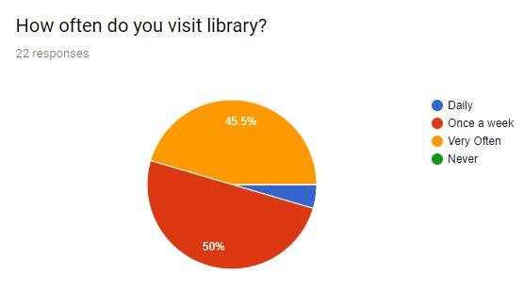

Figure 69 SURVEY REPORT 1
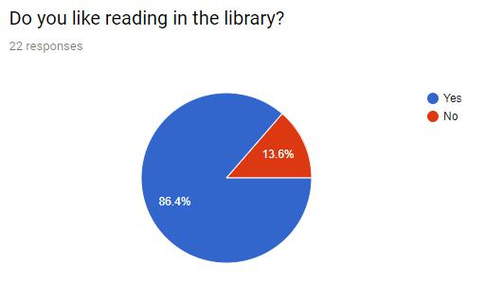

Figure 70: SURVEY REPORT 2

76

Padam-Gurung(17031979)

FYP PROJECT: LIBRARY MANAGEMENT SYSTEM 05/08/2019
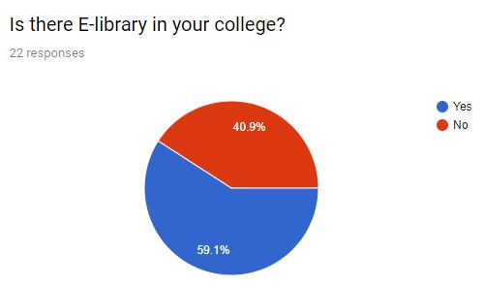

Figure 71 SURVEY REPORT 3
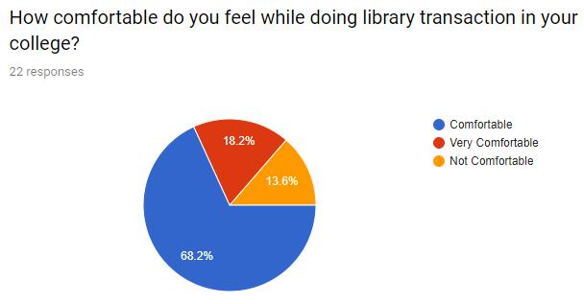

Figure 72: SURVEY REPORT 4

77

Padam-Gurung(17031979)

FYP PROJECT: LIBRARY MANAGEMENT SYSTEM 05/08/2019
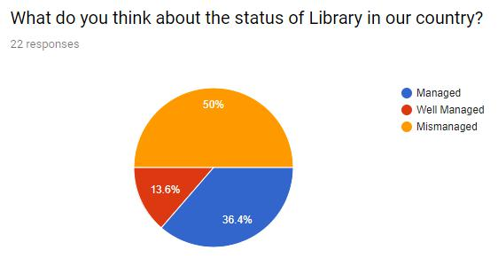

Figure 73: SURVEY REPORT 5

78

Padam-Gurung(17031979)

FYP PROJECT: LIBRARY MANAGEMENT SYSTEM 05/08/2019

Appendix-B.

Gantt chart
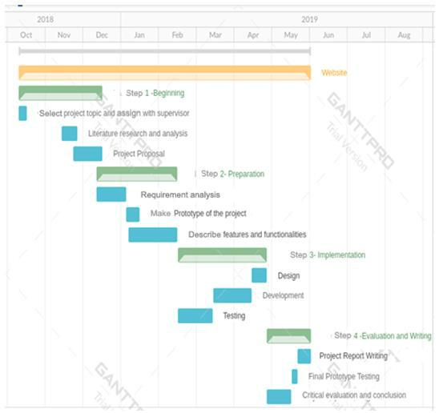

Figure 74 Gantt Chart

79

Padam-Gurung(17031979)

FYP PROJECT: LIBRARY MANAGEMENT SYSTEM 05/08/2019

Appendix-C.

Software Requirement Specification

Purpose

The purpose of SRS is to provide software requirement report for the Library Management System. This is a web-based application for monitoring and controlling the book transactions in the school/college library. This system is easy to use for both beginner and advanced users since it is very easy to operate with the easy process for its implementation. This system will fulfill most of the requirements of librarian for the record keeping of library books systematically and easily.

Intended Audience

The SRS is intended for the developer who review the project and more easily understand where they should increase their effort to improve and add new features.

Project Scope

The purpose of Library Management System of School is to manage library properly and systematically. This system shows the details of books that are kept in the school library so admin access information easily. After getting the membership in the library, member should visit the library personally for borrowing his/her desired books. This library management system is dynamic system so admin keep the record of books and members dynamically which is very easy to operate and they update delete and edit the books and members easily in this system.

80

Padam-Gurung(17031979)

FYP PROJECT: LIBRARY MANAGEMENT SYSTEM 05/08/2019

Overall description:

Product perspective

The Library Management System of School is very useful website for schools of Nepal. It helps them to manage library-books.

Product features

By the use of website Admin easily provide the require book. Member view the book detail. The member easily search for the book according to the requirement.

User characteristics:

In this system, there are two types of user. One is admin and another is member. Member visit the page as registered member. Admin they post the books. Member view the books and borrow it. The user visit the webpage on both mobile and PC.

Operating environment

The Web site will run in any web browser and have mobile view, which will help site to open in mobile browser too.

Constraint

The internet is necessary to utilize the program. The in formations cannot be viewed without internet by the user. The confirmations of uploading require information is likewise done by administrator.

Assumption

The web application do not have any assumption. It just need web browser and internet to run.

81

Padam-Gurung(17031979)

FYP PROJECT: LIBRARY MANAGEMENT SYSTEM 05/08/2019

System features

- Admin module: In this module, admin login in this system and update the details related to the books, users and members.

- Announcement module: In this module admin announce the related news.

- Add Book module: In this module, admin enter the details about new books such as Book name, Author name, Publisher’s name, etc.

- Add Member module: In this module, admin enter the name and details of the new members of library which might be students or teacher.

- Borrow book module: In this module, admin view the details about book which has been borrowed by a student's and along with that details of that student.

- Stop Counting fine module: In this module, admin stop counting fine on the book which has been returned by the student which was borrowed by him/her before.

External Interface Requirement:

User interface:

User interface is same for all web browser.

Hardware interface:

Internet is required for website to view require information. Therefore, internet is the basic need of website to run.

Software interface:

The website need permission of admin to login. When the all the detail requirement of user/member is fulfilled the user/member get their requirement.

82

Padam-Gurung(17031979)

FYP PROJECT: LIBRARY MANAGEMENT SYSTEM 05/08/2019

Communication interface:

Internet is required for all the activities. Without internet, the website will not

open.

Non – Functional Requirement:

- User should able to view the page.

- The website should be user friendly.

- User should be able to register themselves.

- User should able to get their requirement.

83

Padam-Gurung(17031979)

